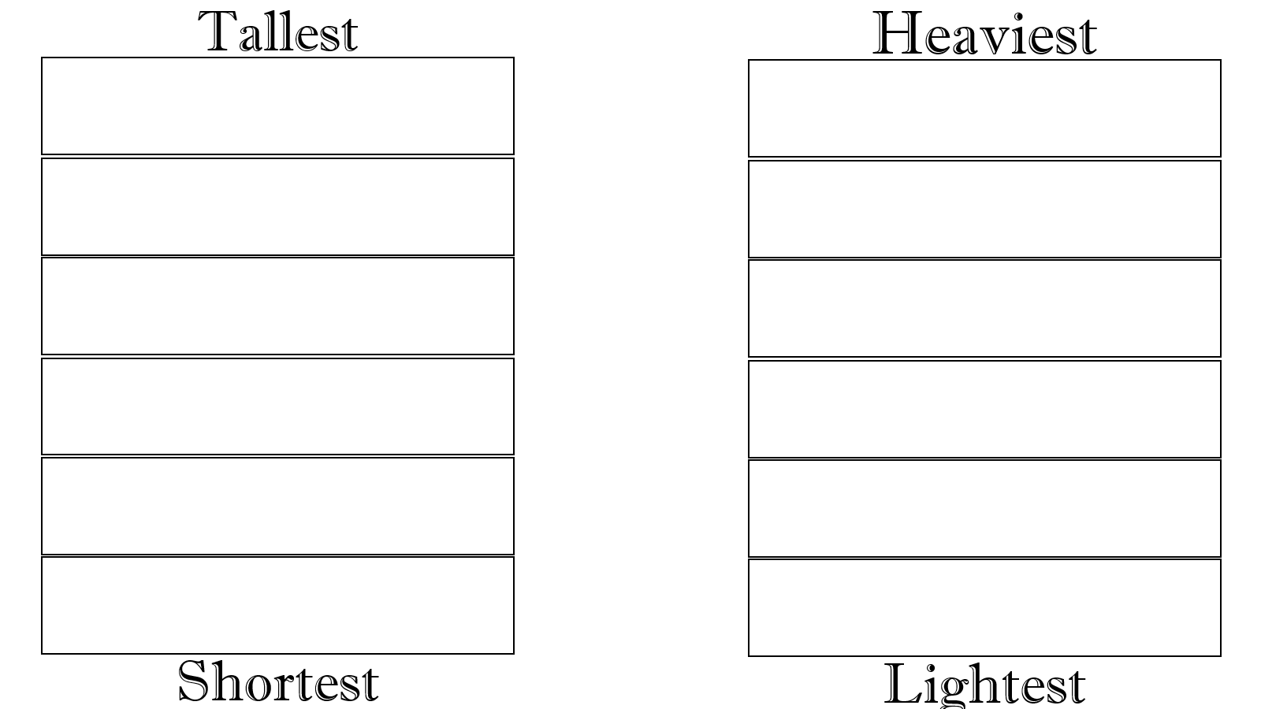

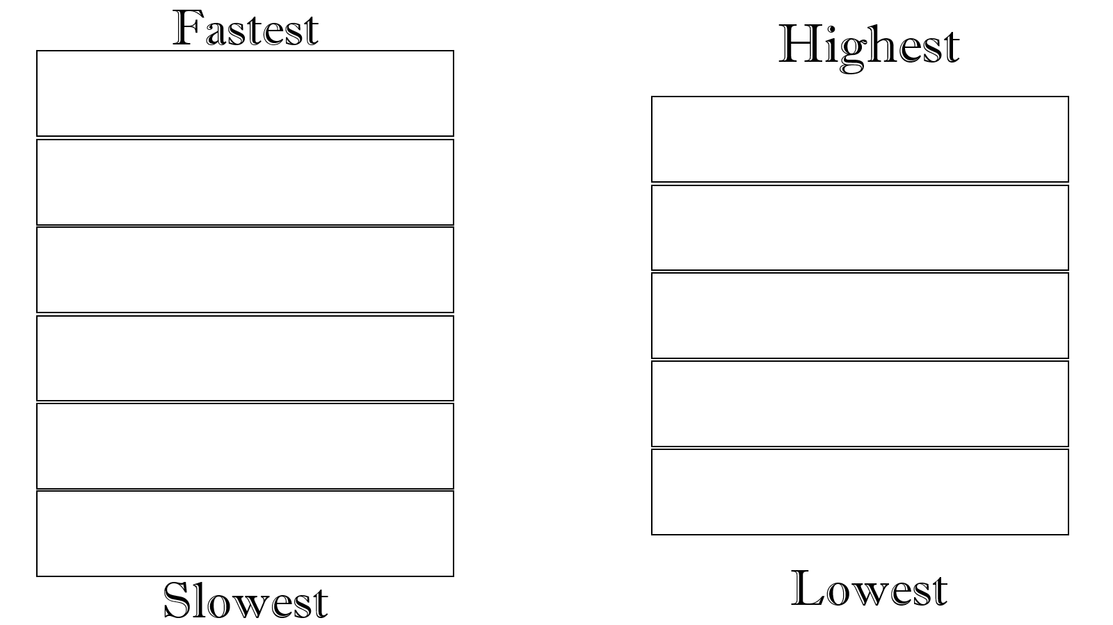

- Jina is taller than Brian, but Jina shorter than Ashley.
- Alex is shorter than Jina and Ashley, But Alex is taller than Missy.
- Suho is taller than Brian and Missy.
- Ashley is shorter than Suho, but Ashley is taller than Jina.
- Brian is taller than Missy, but shorter than Alex.

- Yumi is heavier than Sam.
- Sam is heavier than April.
- April is lighter than John.
- Joy is heavier than Minho.
- Minho is lighter than April.
- John is lighter than Sam.
- April is heavier than Joy.
- The ostrich is slower than the sailfish.
- The sailfish is faster than the cheetah.
- The ostrich is faster than the lion.
- The sailfish is slower than the peregrine falcon.
- The cheetah is faster than the ostrich.
- The lion is slower than the pronghorn antelope.
- The pronghorn antelope is slower than the ostrich.

- Kilimanjaro is higher than Baekdusan.
- Denali is lower than Aconcagua.
- Aconcagua is higher than Kilimanjaro.
- Denali is higher than Mauna Kea.
- Baekdusan is lower than Muana Kea.
- Kilimanjaro is higher than Muana Kea.
- Kilimanjaro is lower than Denali

