If I had a Million Dollars Worksheet
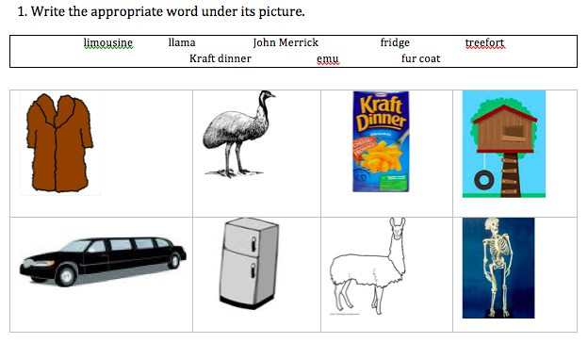

If I had a million dollars, I would…

