_____________ eats _____________.
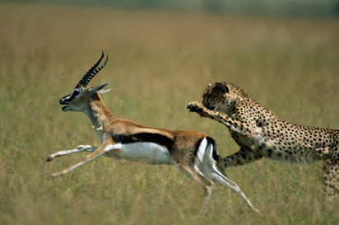

Video:
- Who is the predator?

- Who is the prey?

- Where is it?

- What is the shark’s name?

- Jumping out of the water =

- Not a real seal =

