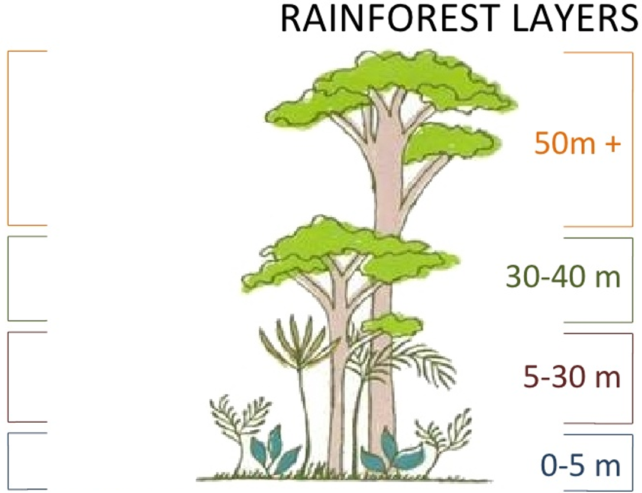
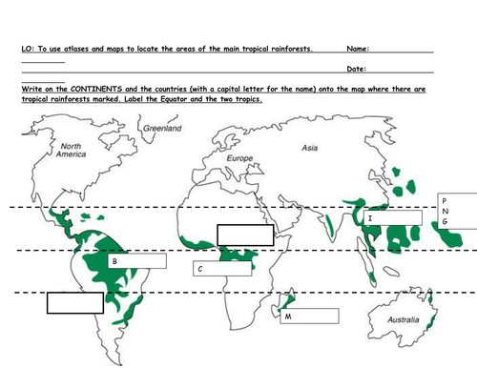

Amazing Amazon
11. How long does it take rain to hit the ground?
10. What is the largest rain forest in the world?
9. What does the Harpy Eagle eat?
8. What is the 3rd largest cat in the world?
7. Should you eat the “Angel’s Trumpet”?
6. About _____% of anti-cancer drugs are from the Amazon rainforest.
5. There are over 300 types of ______ in the Amazon.
4. Who are the loudest birds in the Amazon?
3. How many tribes have never talked to the rest of the world?
2. The Amazon is the ______ of the planet.
1. How many bridges go over the Amazon River?

