The Three Diablos

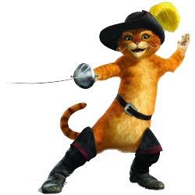
- What do they need to find?

- Who stole the heart?

- What food will they eat?

- What is it called when you don’t have parents?

