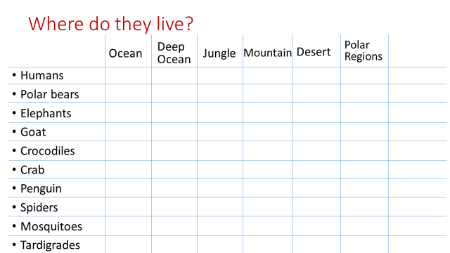

How do tardigrades survive?

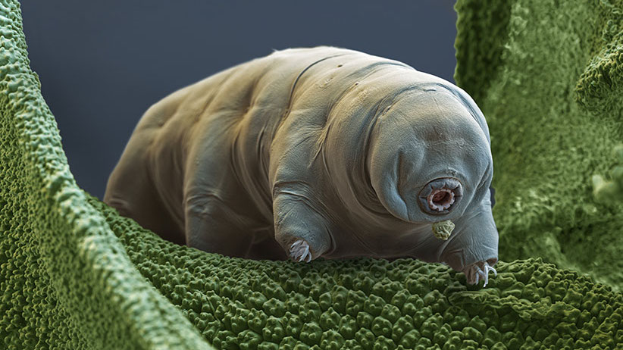

Hard / Tough / Thick Skinned

Soft / Mushy / Squishy

Hairy / Fluffy / Furry

Hairless / Bald / Bare

Feathery

Scaly

Slimy / Greasy / Slippery

Smelly / Stinky

Bumpy / Rough

