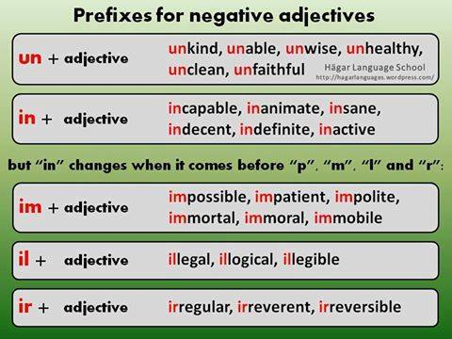
Able – I can do it
Unable –

Wise – smart, knowledgeable
Unwise –

Capable – I can do it.
Incapable –

Animate – It moves.
Inanimate –

Sane – Not crazy
Insane –
Active – Moves a lot.
Inactive –

Patient – I can wait.
Impatient –

Polite – Nice, not mean
Impolite –

Mortal – I can die.
Immortal –

Legal – I follow the rules
Illegal –

Logical – It makes sense (I understand)
Illogical –

Legible – I can’t read it.
Illegible –

Regular – Normal
Irregular –

