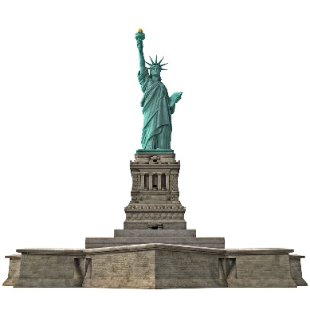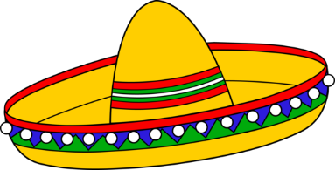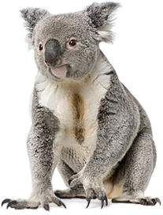

___________ animal ____________ hat __________ statue

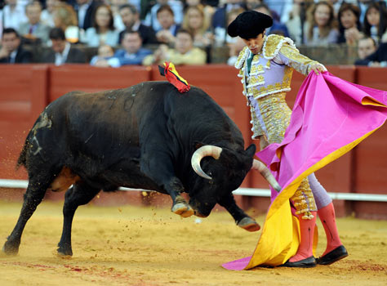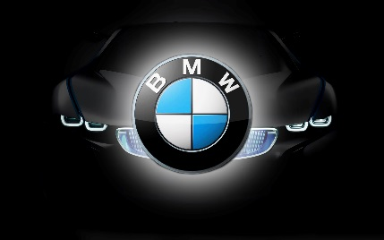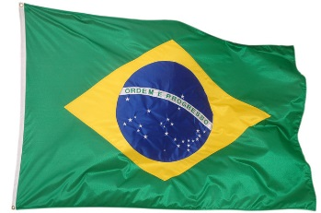

_____________ flag ___________ sport ____________ car

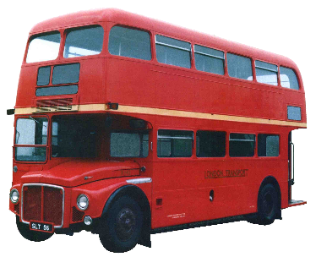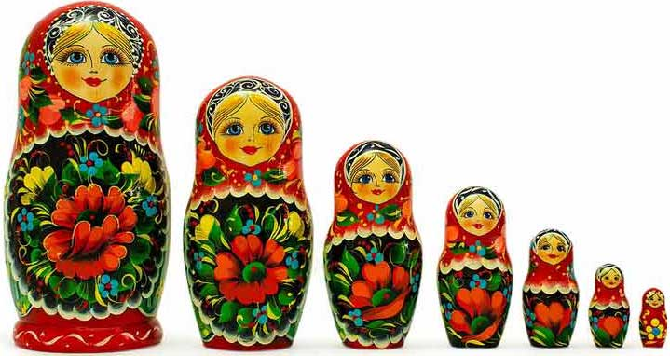

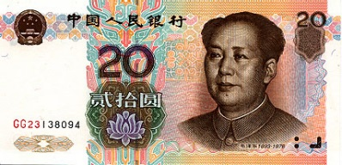

____________ dolls ____________ bus ____________ money

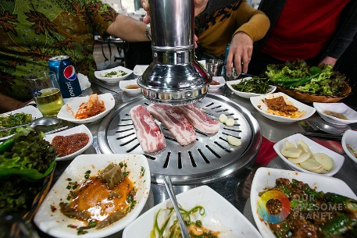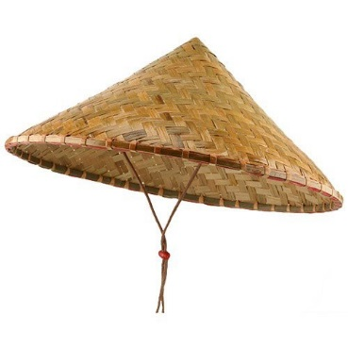

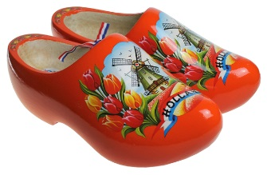

____________ hat _____________ shoes ___________ food

A Japanese Dress =

An Antarctic Animal =

A French Tower =

A Dutch Flower =

Indian Food =

A Canadian Sport =

Italian Food =

German Candies =

Italian Car =