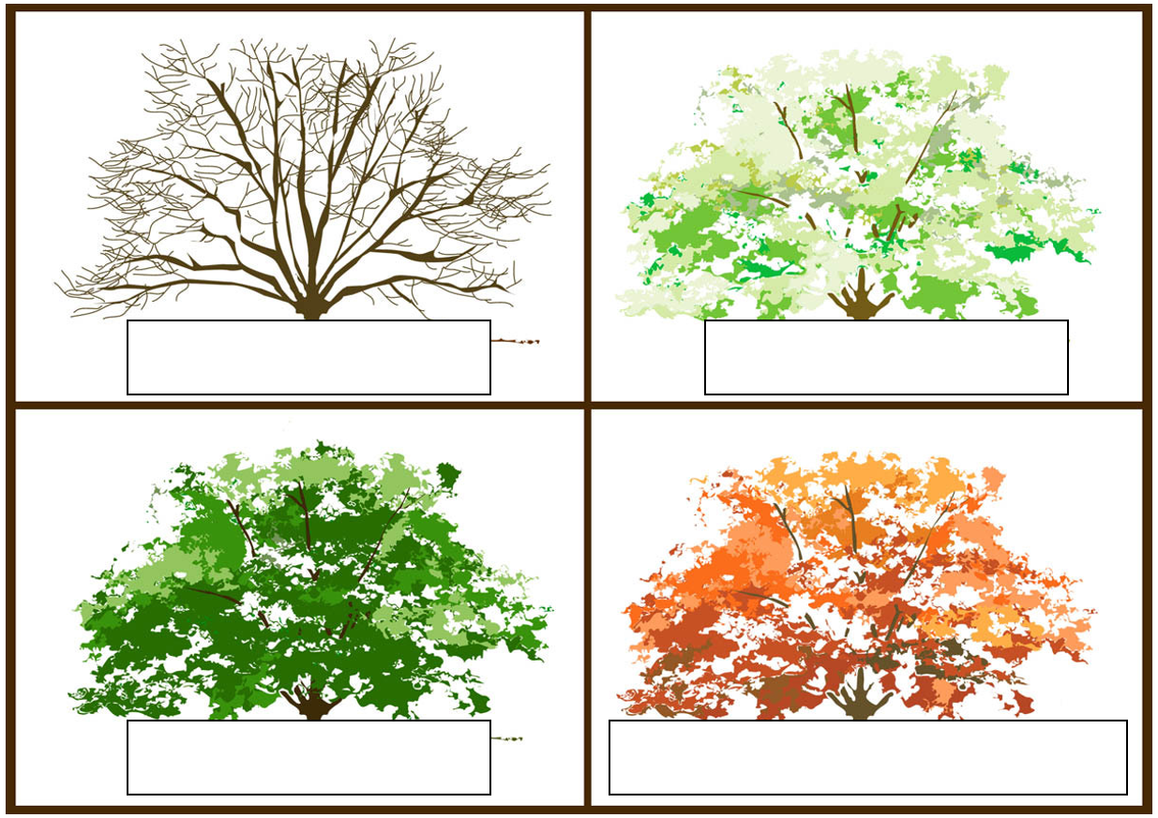

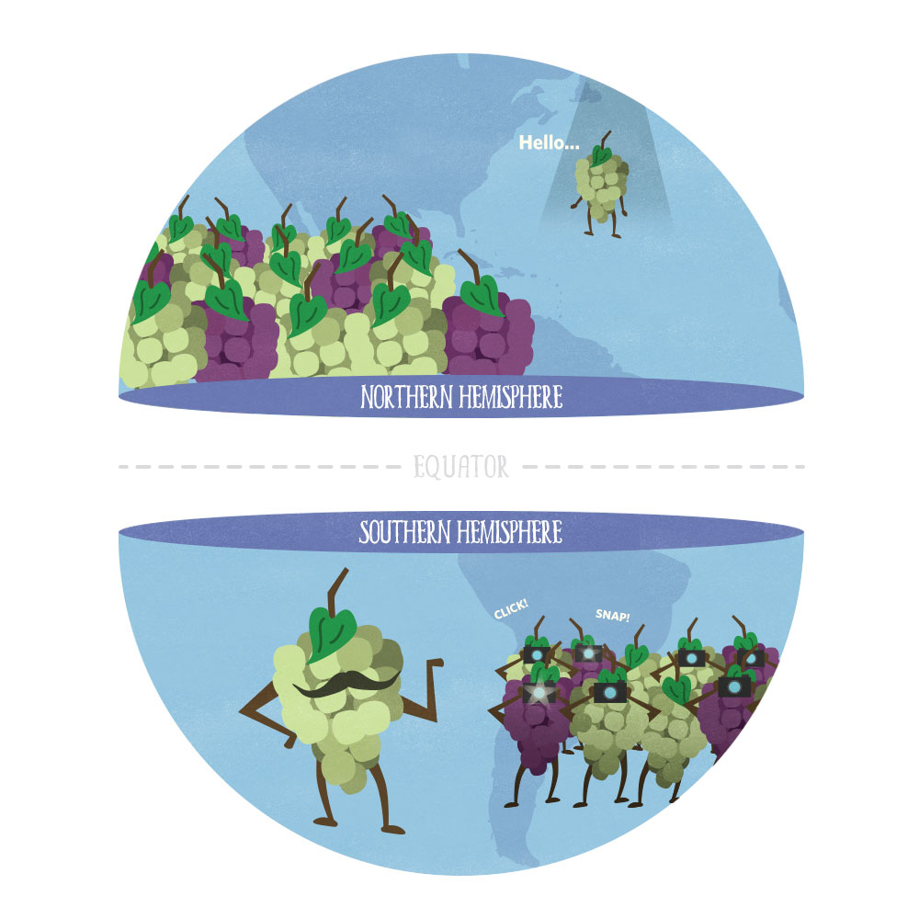

What is **tilt**?

**Bill Nye the Science Guy Questions:**

Why do we have seasons?

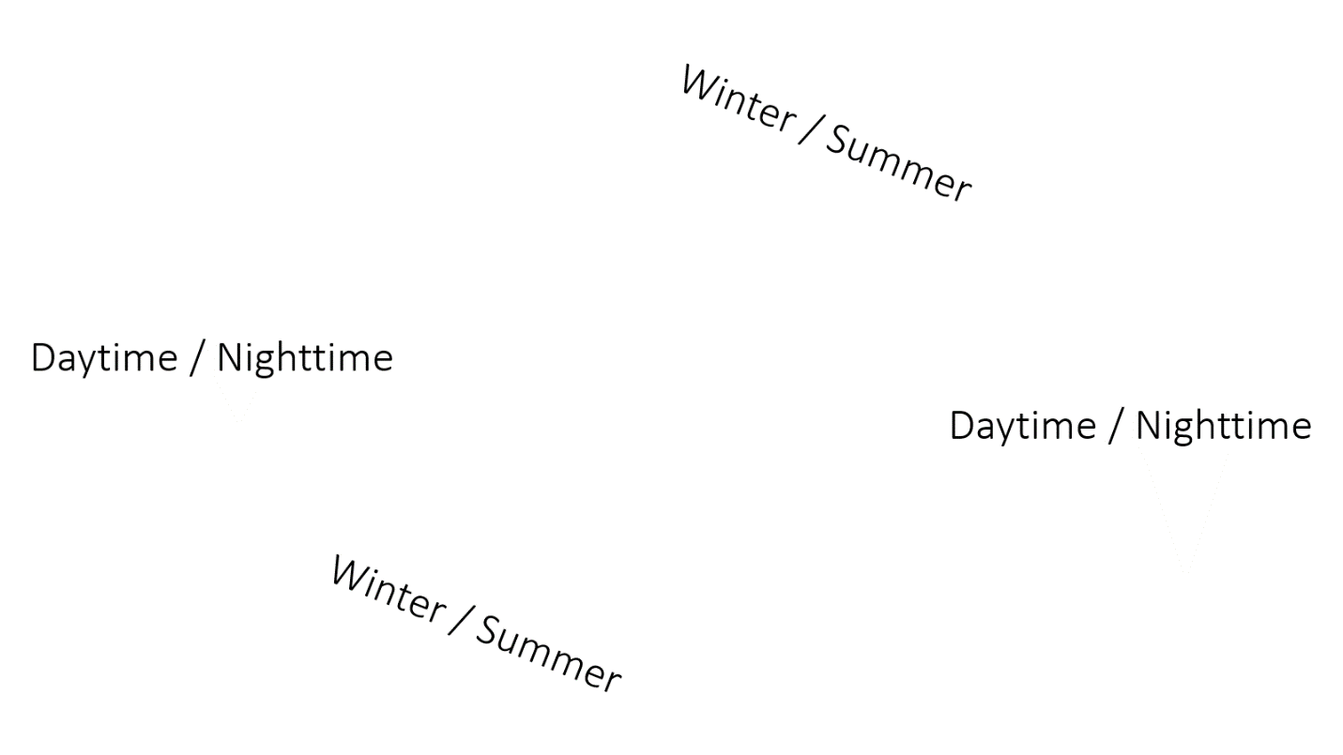

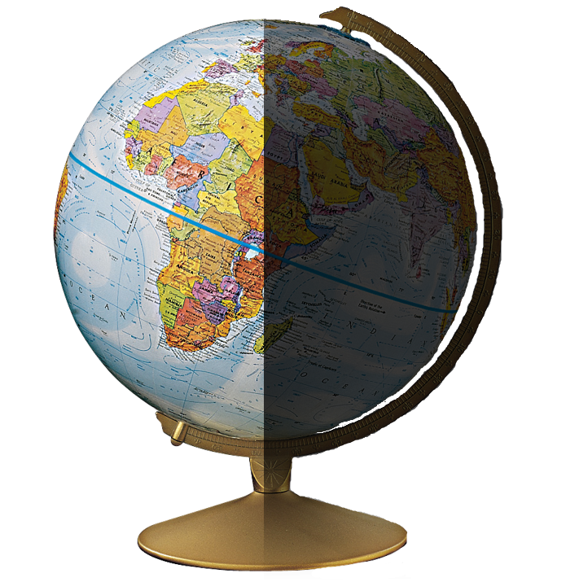

Where are the **coldest** places on earth?

Where are the **warmest** places on earth?