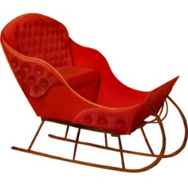
- What is it?

- A small road:
- Like shining:
- Something nice to see:
- An area with no trees:
- Make plans:
- Not scared:
- Exciting:
- I feel cold:
- People who live in the arctic circle:

