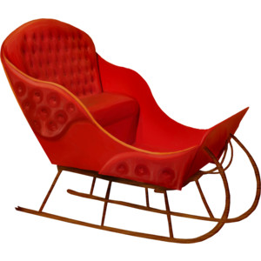
Sleigh bells ring
Are you listening
In the lane
Snow is glistening
A beautiful sight,
We're happy tonight
Walking in a winter wonderland
Gone away, is the blue bird
Here to stay, is the new bird
He sings a love song,
As we go along
Walking in a winter wonderland
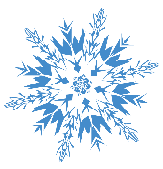
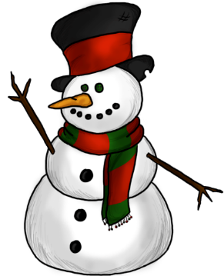
In the meadow we can build a snowman
And pretend that he is Parson Brown
He'll say are you married
We'll say no man
But you can do the job
When you're in town
Later on
We'll conspire
As we dream by the fire
To face unafraid
The plans that we've made
Walking in a winter wonderland
Sleigh bells ringing
Are you listening
In the lane
Snow is glistening
A beautiful sight,
We're happy tonight
Walking in a winter wonderland
Gone away, is the blue bird
Here to stay, is the new bird
He sings a love a song
As we go along
Walking in a winter wonderland

In the meadow we can build a snowman
And pretend that he's a circus clown
We'll have lots of fun with Mr. Snowman
Until the other kiddies knock them down
When it snows
ain't it thrilling
Though your nose, gets a chilling
We'll frolic and play, the Eskimo way
Walking in a winter wonderland
Walking in a winter wonderland

