What holiday is it?

What costumes did you see?

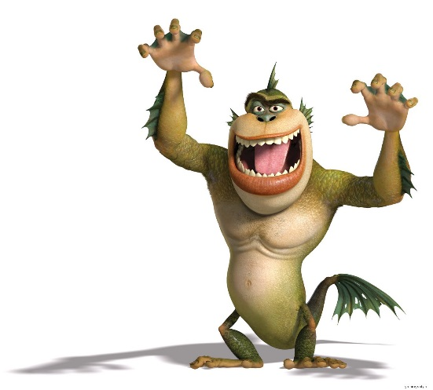

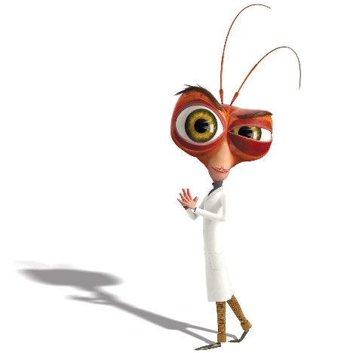

Who are they?

What do the carrots do?

What happens when you shoot a vegetable?