Africa Things
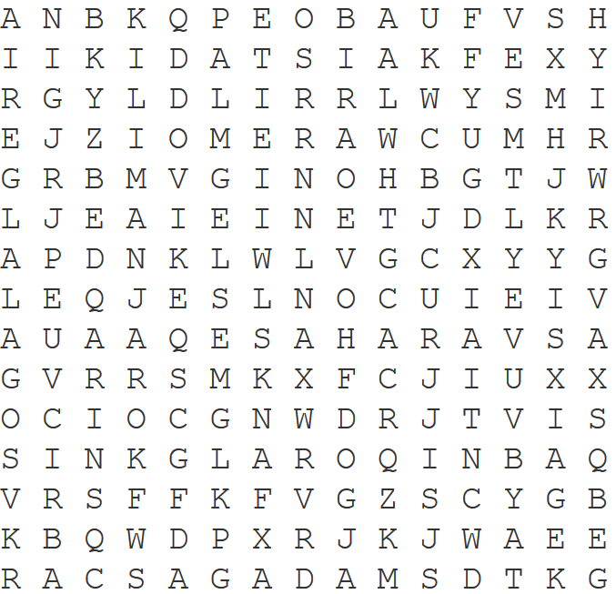
Find 10 words from today’s lesson:

______________ ______________ _____________

______________ ______________ _____________

______________ ______________ _____________

_____________

