Baule Goli Mask:
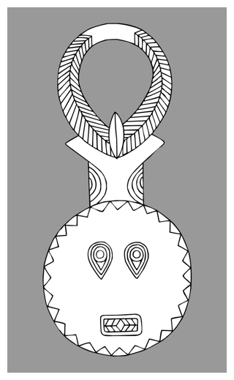
The _______ face represents the life-giving force of the ____ and the horns symbolize the great power of the _________. The mask is made of ______ with two holes cut into the eyes to enable the wearer to see. The ___________ mouth is also typical of this type of mask.

Biombo Mask
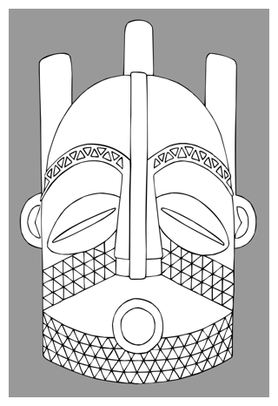
Biombo masks are usually carved from wood and colored with red "tukula" powder, a dye made from the camwood tree.
The eyes are a typical _______ ______ shape. A ________ checkerboard design is used to decorate the ____________ and the planes of the face.
The three forms at the back of the head represent the Biombo _________. __________ are often attached to the top of Biombo masks.
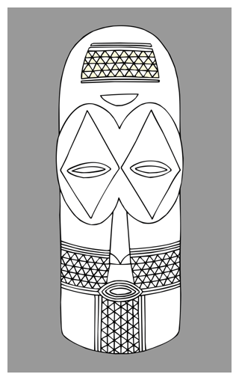
Goma Mask
Goma masks are easily identified by their ___________ cylindrical forms, domed heads, large _________ eye sockets with protruding eyes and their decoration with geometric abstract patterns.

Lulua Mask
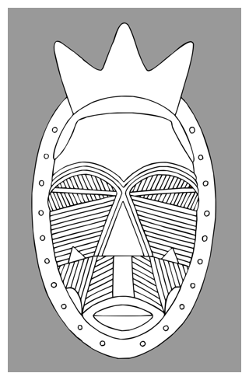
The Lulua were famous for decorating their ________ with marks and tattoos. They also applied these designs to their sculptures and ________.
The pointed forms on the top of the head represent the Lulua ________.
The Lulua are related to the Lwalwa and like them, the men _____ and the women ________.

Lwalwa Mask
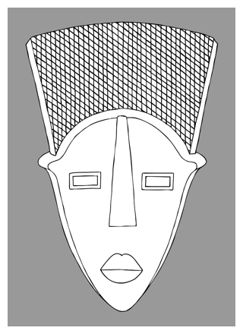
Lwalwa masks are stylized using simple geometric forms to represent the _________ of the face. The eyes of the mask are ________ holes and the nose is a long flat ________ that often stretches to the top of the head. The _________ are reduced to small bumps and a stylized mouth projects from above a __________ chin.

Woyo Mask
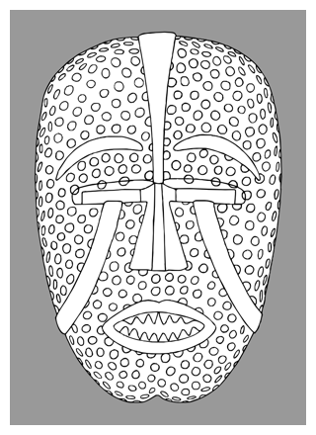
Woyo masks are usually painted with ____________ colors against a white background and are often worn with a full length costume made from __________ leaves.
The colors used in a Woyo mask have symbolic meaning and are sometimes ___________ to renew its power.

