Has / Have
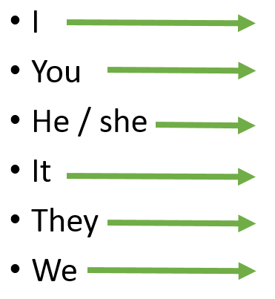
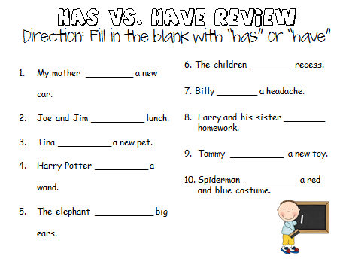

Has / Have / Had
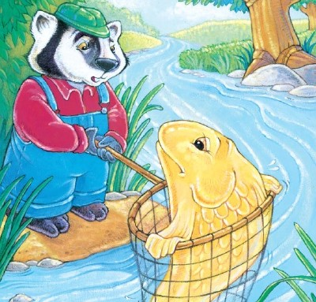

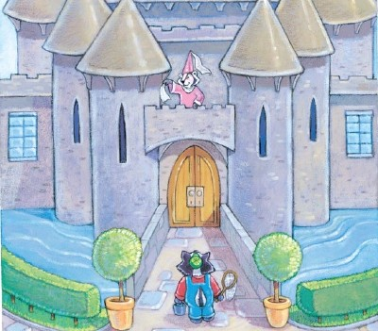
He _________ a magic fish.
She __________ a hut.

She __________ a castle.

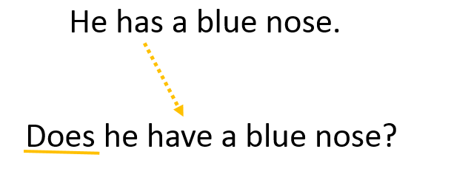

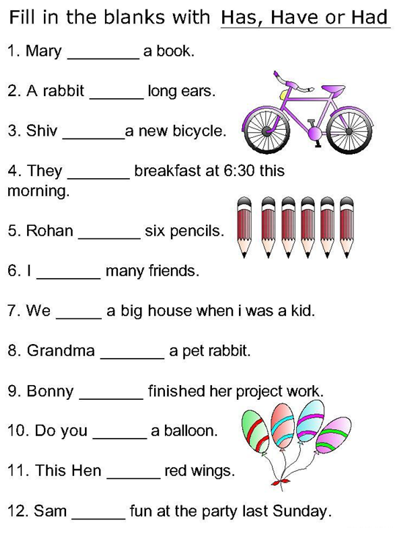

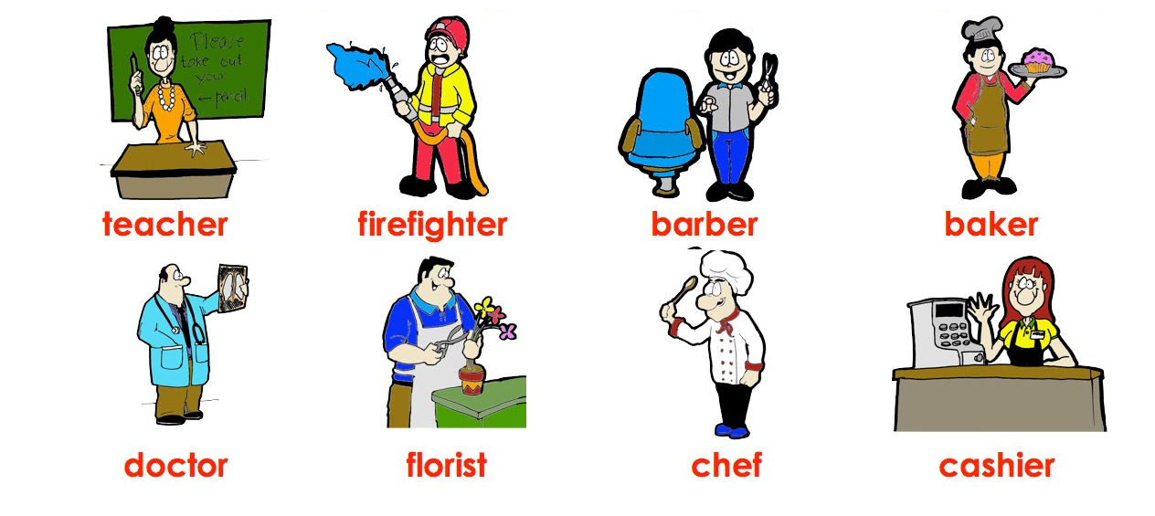

Does the doctor have an x-ray?

Does the florist have flowers?

Does the cashier have scissors?

Does the firefighter have water?

Does the chef have soup?

Does the barber have a cake?

Does the teacher have an eraser?

