Primary Colors

Secondary Colors
+ =

+ =

+ =

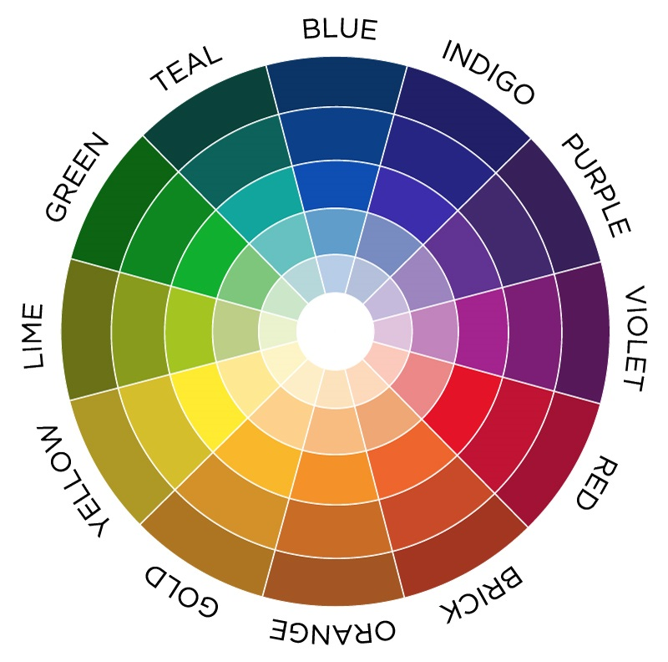
Tertiary Colors / Shades

Patterns

Polka Dots:

Stripes:

Plaid:

Solid:

