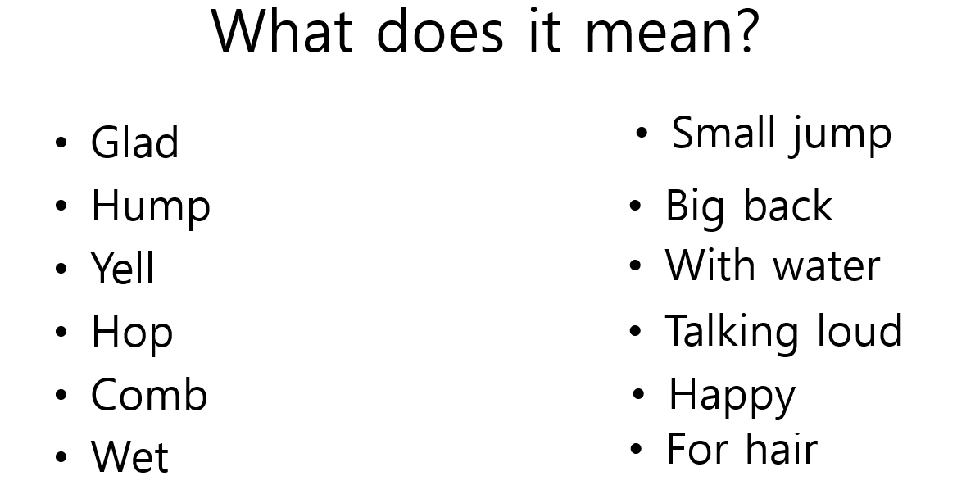

Read and Listen:

- The Wump has ___________.
- Can a Nook cook?
- What does a Zans do?
- What sport does the Gox like?
- Yings like to ___________.
- What does a Yink Drink?
- What does a Yop do?
- What is special about Zeds?
- How do you play ‘Ring the Gack’?

