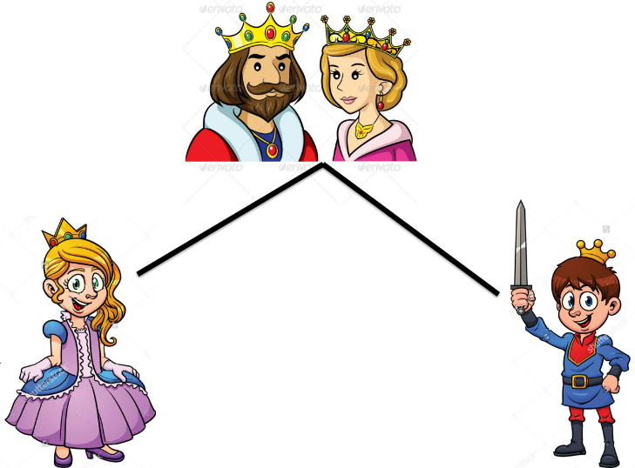
Lower Nobility –
Middle Nobility –
Protects the castle –
King or Queen’s soldier –
Makes things from metal –
Makes things from wood –
Makes things from stone –
Makes bread –
Cleans the castle / palace –
Makes candles –
Takes money from people to give to the nobility –
Sells things –
Copies writing -
Tells people things –
Lower church –
Middle church –
Upper church –

