Medieval Jobs
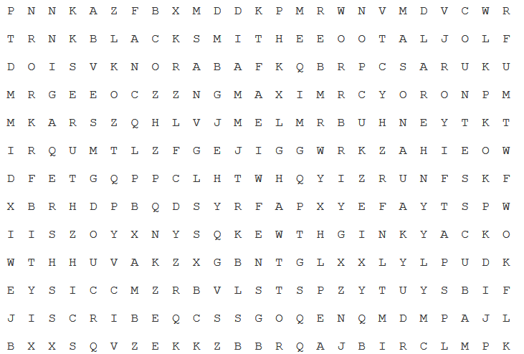

Baron / Baroness
Lord / Lady
Count / Countess
Guard
Knight
Jester
Blacksmith
Carpenter
Mason
Baker
Maid
Candlemaker
Tax Collector
Merchant
Scribe / Herald
Monk
Priest
Bishop

