Champion Name: ______________________________________

Stats (40 total)

 (minimum 5 / Maximum 15)

Armor:

Weapon:

Damage:

Health:

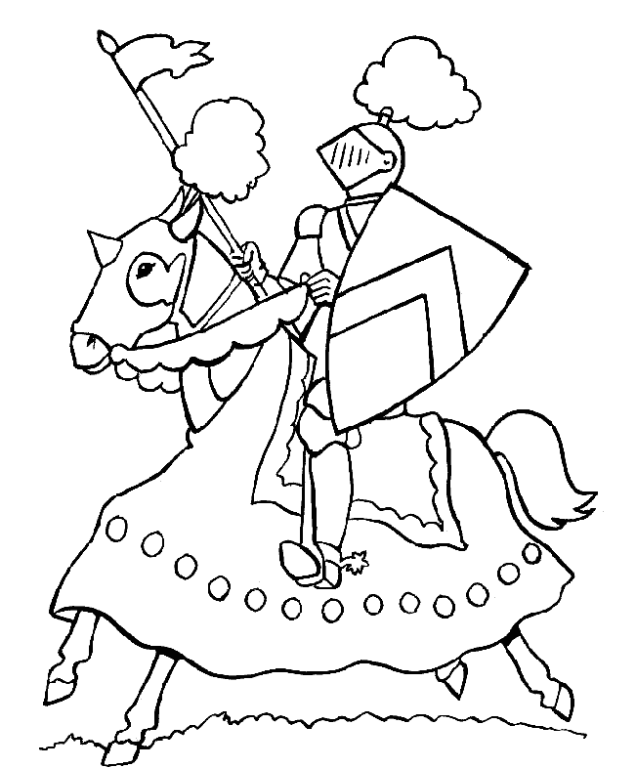

Champion Name: ______________________________________

Stats (40 total)

 (minimum 5 / Maximum 15)

Armor:

Weapon:

Damage:

Health:

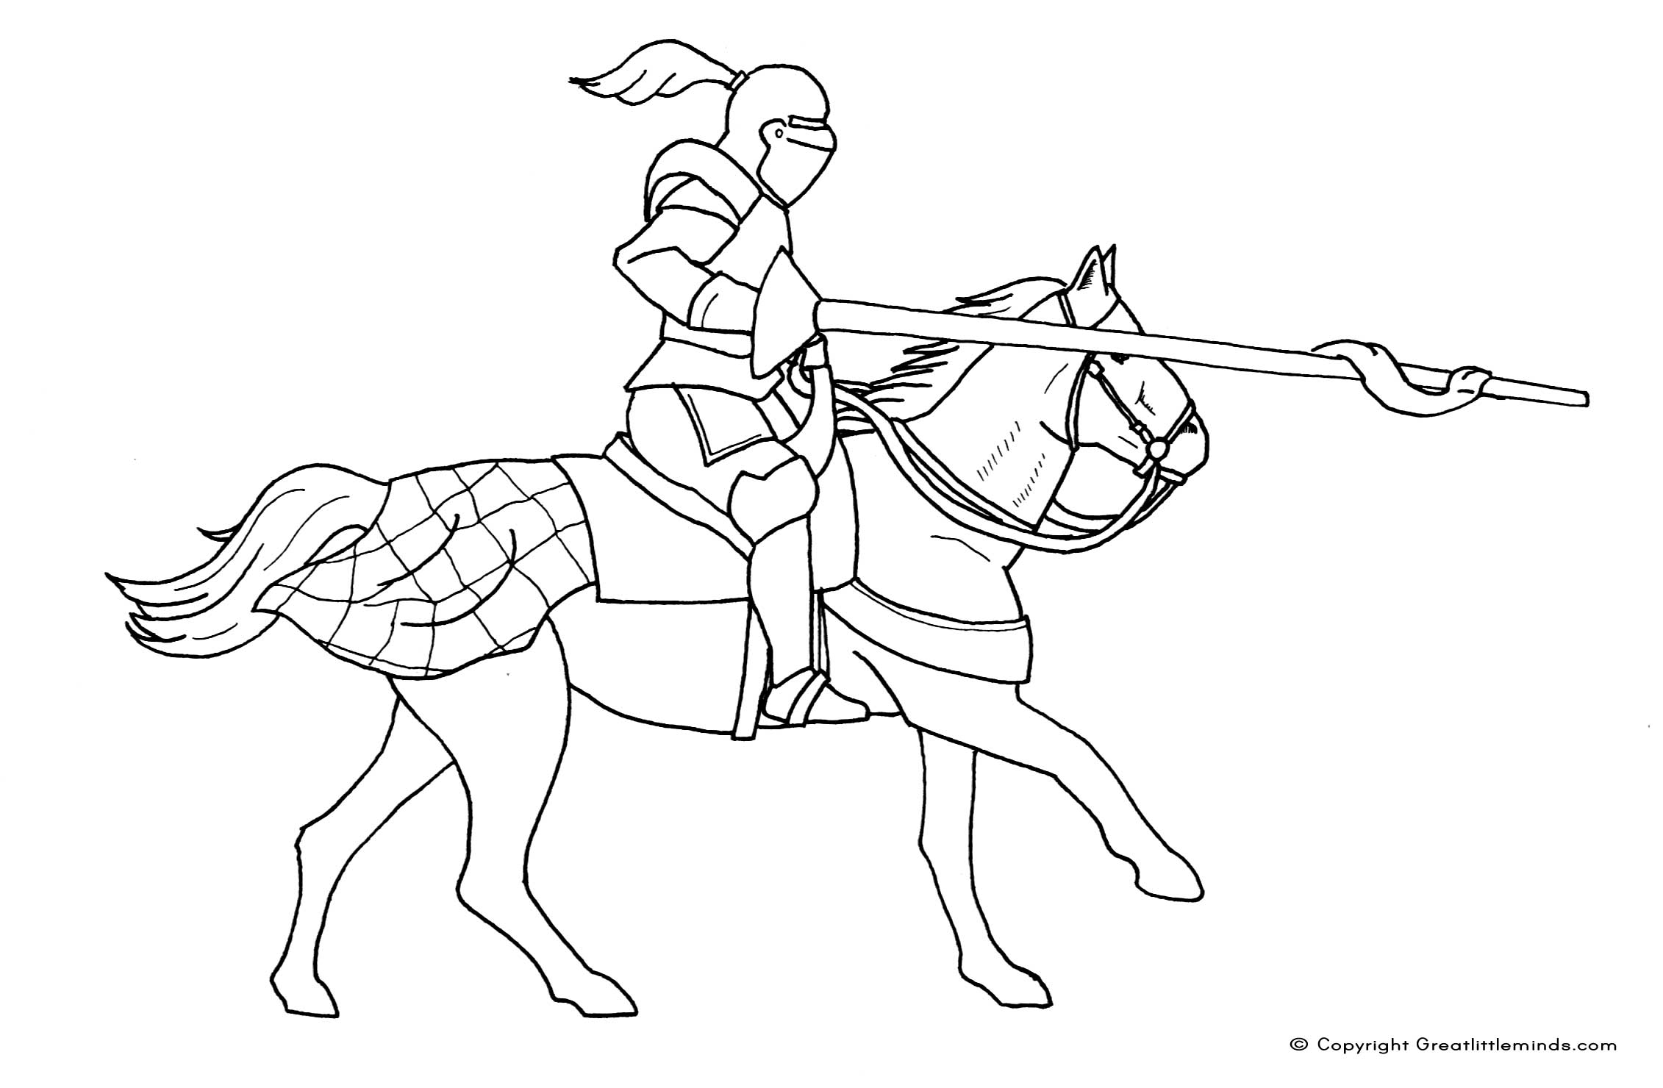

Champion Name: ______________________________________

Stats (40 total)

 (minimum 5 / Maximum 15)

Armor:

Weapon:

Damage:

Health:

