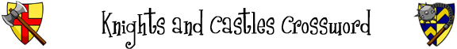
 |  | 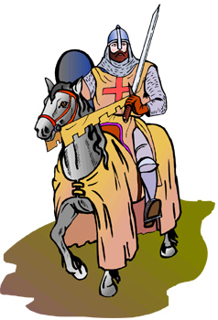
Across  3. A circle of water around a castle.  6. What a knight rides.  7. A large weapon that fires big stones.  9. A place where prisoners are kept in a castle.  10. Metal gloves worn by knights.  12. A weapon used by knights.  13. Somebody who helps a knight get ready for battle.  14. A weapon that can be thrown.  15. Somebody who blows the trumpet in the castle. | Down  1. Knights wear this to protect their bodies.  2. A competition between two nights where they try to knock each other off of their horses.  4. A weapon that can also be used to chop wood.  5. A soldier who fires a bow.  6. Something knights wore on their head.  8. A fortress where a knight might live.  11. What you shoot from a bow.  13. Something a knight holds in his hand for protection.

© 2006 www.bogglesworldesl.com

