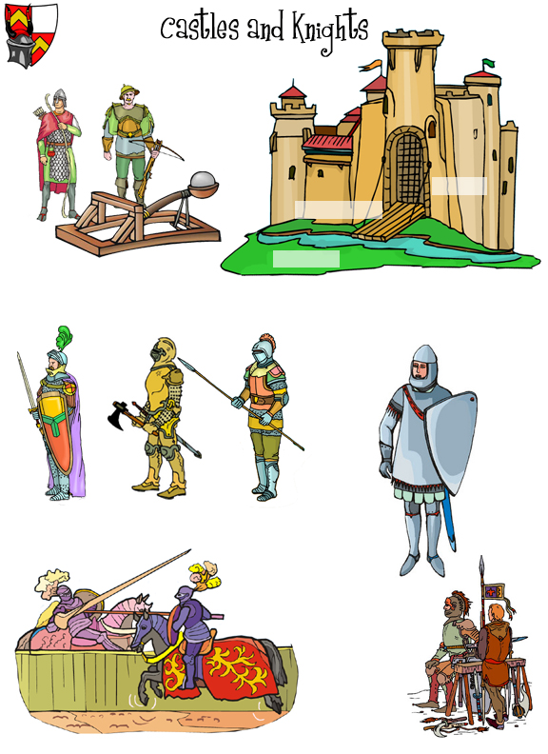
Long-ranged Weapons
Hand-to-Hand Combat
Armor
Jousting
Squires
Castles

