The Value of Reading
Reading for pleasure is one of the most effective ways to learn a second language. We should not underestimate the value of reading. But teaching this skill has its challenges. In this session we will examine some techniques for teaching reading. We will look at reading activities and how to check for comprehension. Since this is the last session of IETTP, the goal is to give you some practical skills and ideas to use in your classroom. Our focus, therefore, will be on classroom materials, games and activities.
Reading is a powerful tool for second language acquisition. You have already been exposed to SSR (sustained silent reading) in this program and are familiar with its effectiveness. Stephen Krashen is the biggest proponent of this idea. In his Conduit Hypothesis, he explains how SSR can help the language learner. The first stage is the use of stories. Children love stories and it piques their interest in the second language. Read-alouds and hearing stories help students learn a second language by exposing them to new vocabulary, grammar, structure and by making the written texts more comprehensible. The second stage is self-selected recreational reading, similar to SSR. This type of reading helps the learner prepare for academic reading. Finally, stage three is narrow academic reading. In this stage, the reader chooses a topic or area that is interesting to them. They will seek out academic texts that interest them. This is an extension of stage 2. The difference is that stage 2 has a wider net. More subjects, particularly fiction, are explored in stage 2.
Some other names for SSR can also tell us a little bit about its effectiveness: Free Uninterrupted Reading, Drop Everything and Read (DEAR), Self-Selected Reading, Free Reading, Recreational Reading, etc. What these names tell us is that this type of reading is to be done in a silent manner and without interruption. Most importantly, students are allowed to choose their own material. The material is not to be tested, but just for fun. Implementing a program like this at school is difficult. As teachers, we want to be involved in the classroom and we need to show results via tests. But we also want to foster a love of reading and not discourage students by having them analyze the text incessantly. Let’s see if we can use aspects of SSR in our classes.
One of the most difficult things to do is to find interesting material for students to read. Having material that students want to read is important as a motivation tool. In SSR, we need to provide a lot of different materials that might be of interest to students. Similarly, in the classroom it is useful to have varied reading material during the semester. But what kinds of material are available? For elementary students there are fairy tales, short stories, picture books, activity books, graphic novels, choose your own adventure books, and newspaper articles to name a few. One useful website you might want to visit is www.getepic.com. Using multiple types of media will help to keep things interesting for the students. But we also need to consider the level of the material.
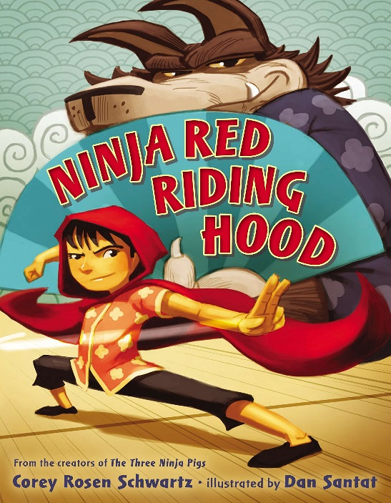
One of the issues with finding good reading material for second language education is the level of the material. Generally the students are older than target age for the materials available. For example, stories written for young children are often the appropriate level, but they are not interesting for students because they are too old for that type of book. By grade 3 or 4 students start appreciating having a story arch. Fairy tales are useful in this regard depending on how they are written. Some are familiar to the students, so reading is a little easier to comprehend, but it might also be boring. Some authors have rewritten fairy tales to make them more accessible, while others have put a new spin on them. Some examples include: Goldilocks on CCTV, Ninja Red Riding Hood, The True Story of the Three Little Pigs, Goldilocks and the Three Dinosaurs, The Three Little Wolves and the Big Bad Pig, and Snow White in New York. These stories allow you to take familiar stories and use them for older students. The stories will still sound fresh to them. During this session we will look at some of these books and read (an eBook I made based on) the Tortoise and the Hare. Keep in mind that student interest is more important than having an appropriate level for all of the students.
As students get older, they start craving materials that are relevant to them. Real world examples, and relatable stories are important to students in grades 5 and 6. Of course, this is not true for all students, but generally this is the trend I have noticed. At this age, newspaper articles, choose your own adventure stories and graphic novels are valuable. News articles in particular are useful as there are websites dedicated to writing articles targeted at ESL students.

Here are some useful news websites:
- breakingnewsenglish.com has the same article written at different levels and also offers review activities for students.
- newsinlevels.com also offers different levels for the same article and usually it has an audio file attached.
- newsineasyenglish.com breaks down their articles by sentence and has a narrating feature.
- You can also try simpleenglishnews.com, newsforkids.net, and teachingkidsnews.com.
- Some news and magazine websites also have kids sections with appropriate articles. The news comes from trusted sources like;
  - National Geographic (kids.nationalgeographic.com/)
  - TIME magazine (timeforkids.com/)
  - Smithsonian (tweentribune.com/)
  - CBC (cbc.ca/kidsnews/)
  - and BBC (bbc.co.uk/worldservice/learningenglish/language/).
- Wikipedia also has a simple English setting (simple.wikipedia.org)
To test if you are presenting appropriate material, you can use the 5 finger test. As you or the students read, they will raise a finger for each word they don’t know.
0-1 Fingers – too easy
2-3 Fingers – good
4-5 fingers – probably too hard to read alone

The 6 Reading Skills
With productive skills (writing and speaking) it is much easier to test students, it much more difficult with the receptive skills (reading, listening). This is one of the biggest obstacles in creating good reading lessons. Unfortunately for our students, reading skills are essential and heavily relied upon for KSAT and TOEIC tests. Sometimes this seems to be at the expense of reading for pleasure. For these reasons alone, teaching reading is quite important in Korea.
There are 5 essential reading skills that will make students better readers; phonemic awareness, phonics, fluency, comprehension, and vocabulary. A sixth skills has also been discussed more recently; Oral Language. In the ESL classroom, these skills are also important and our ability to teach these skills will give our students a lifelong advantage in becoming fluent readers. We can tailor our lessons to the levels of our students, but a good mix of these skills will be beneficial to students.
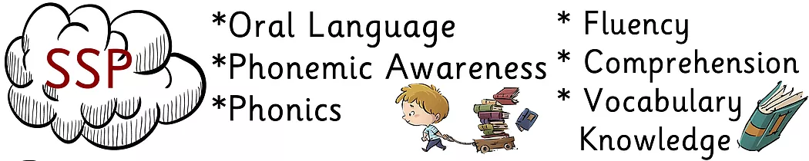https://www.bigsixreading.org/the-six-skills-teaching-framework

Oral Language is newest addition to this list. We used to separate speaking skills and reading skills, but it is becoming quite evident that all of the basic skills (reading, writing, listening, speaking) are connected. In early reading development, knowledge of the oral language is important. When students enter school for the first time, they have very different histories in regards to the oral language they have been exposed to. This acts as a background knowledge to acquire other reading skills. Quite simply put, you need to know the word before you can read it. While the word ‘need’ is a bit strong, clearly you can see the value of oral language in the early stages of reading.
In the ESL / EFL context, students who have had more exposure to English before coming to school will do better at reading. Incorporating oral language into reading language is important for low level students and those that have had limited exposure to English. Picture associating is a great way to do this. Before teaching about the alphabetics in the lesson, why not show some pictures of things that will be discussed? The higher level students and those with more exposure to English can guess what the pictures are with correction from the teacher. This will prime the lower level students to what they will encounter in the lesson. You can also teach songs and games as well as reading to students to prepare them for reading of their own. Don’t underestimate the value of reading to children.
Oral language skills are not limited to vocabulary. Indeed phonology, grammar, morphology, discourse and pragmatics are also a part of oral communication. The amount of exposure to English will also expose children to these parts of speech as well. Children can pick up oral language from other people, TV and other media. Exposure to language will increase their English vocabulary and give them example of what English should sound like (grammar). This foundation will give the students a head start on reading. Oral language is a large factor when beginning to learn English.

Another one of the early reading skills acquired is phonemic awareness. Phonemic awareness is similar to oral language skills. It is the ability to recognize and manipulate different sounds in the language. Phonemic awareness is also the understanding that words are made of different syllables and syllables are made of different sounds. Like oral language, phonemic awareness is an early reading skill that we should teach to students. Phonemic awareness is also about listening skills. It prepares students for the task of reading.
There are a number of factors that influence the level of phonemic awareness including things like economic status and education level of parents, but exposure seems to be overwhelming factor. The authors of the International Reading Association (1998) suggested the following for learning phonemic awareness:
- Offer students a print-rich environment within which to interact
- Engage students with the surrounding print as both readers and writers
- Engage children in language activities that focus on both the form and the content of spoken and written language
- Provide explicit explanations in support of students’ discovery of the alphabetic principle
- Provide opportunities for students to practice reading and writing for real reasons in a variety of contexts to promote fluency.
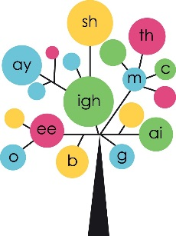
Since phonemic awareness concerns how sounds are put together, there are some common ways to teach it. One method of teaching is to add or subtract sounds to make new words (phonemic deletion and addition). If you take the word “car” and add a “t” sound to it, what new word is created? Students will begin to recognize that each syllable is made of different sounds and that each word is made of different syllables. Rhyming words are another great way to show how words are made of sounds and for students to recognize those sounds (phonemic identification). Therefore, music and sing-a-longs are helpful with developing this skill. Having students find the different sound is also helpful in acquiring phonemic awareness. For example, what is the difference between ‘man’ and ‘moon’ (phonemic isolation)? I also like to use onomatopoeia for learning sounds. It can be a fun way to learn phonetic awareness while also learning new vocabulary, differences in language or culture and gives the students a solid grasp of what the sounds mean. There are more ways to teach phonemic awareness, but the final one discussed here will be segmentation. Here we can ask students, “What is the last sound in cat?” or “What is the first sound in father?” Phonemic awareness can be taught and is a major building block in developing early reading skills.

The next logical step in reading development is phonics. With phonics, students will learn to associate letters with sounds. Oral language skills as well as phonemic awareness will help students to develop this skill as well. As you can probably guess, exposure to English is a major factor. A major hurdle in teaching English as a foreign language is the alphabet. Our students are used to Hangul and the sounds that they can make in that language. While learning a second written language may seem daunting, the fact that students have this background can be helpful. They have already crossed one of the barriers to reading development, recognizing that symbols written can be equated to sounds. There are, of course, many differences between English and Korean that can make learning English difficult. Firstly, Korean is a phonetic language so the association between sound and writing is much clearer. Spelling in English is quite odd at times and can be confusing.
There are about 44 unique sounds (phonemes) in English. There is a debate about the exact number, but the number doesn’t seem to be too high. However the number of ways to write (graphemes) those 44 phonemes is far greater. Using the graphs by David Newman, we can count over 200 ways to spell those phonemes:
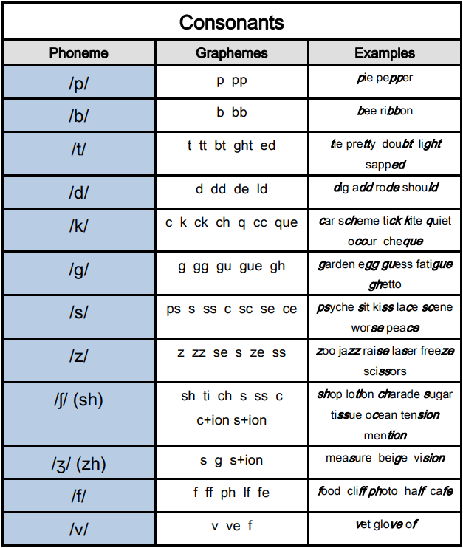
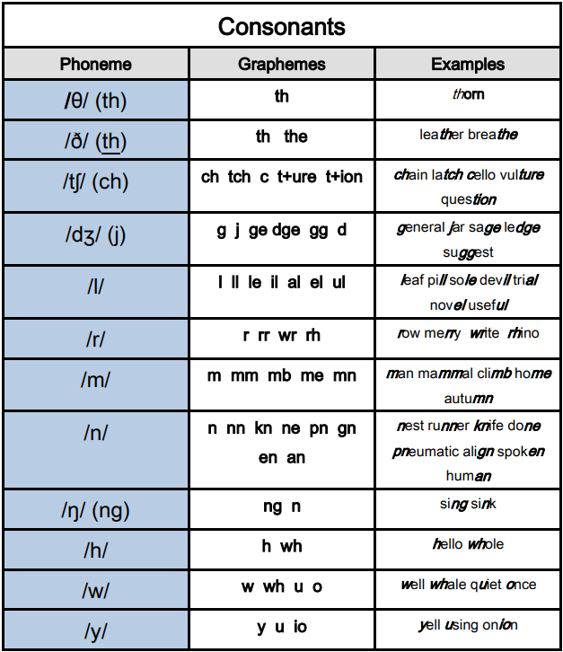

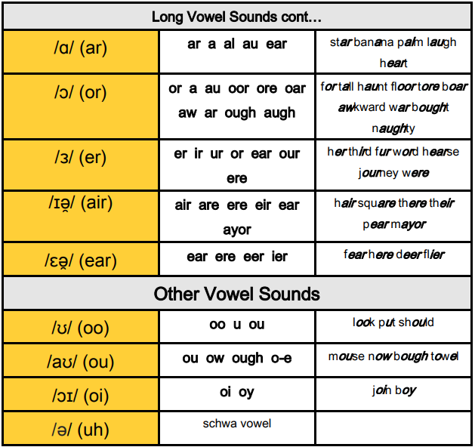
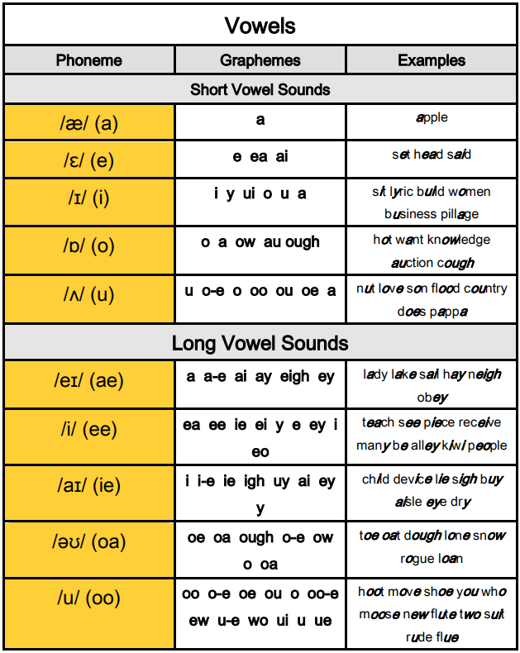

Recognizing these letter combinations and all of the exceptions in English writing is impossible to teach to native students and nearly impossible for students learning it as a second language. And there is a debate over the usefulness of phonics vs. sight words (memorizing whole words instead of their components). Sight words are definitely helpful based on the situation. They can be quite helpful in learning the most common English words. And while memorizing sight words can increase vocabulary quicker, phonics teaches students the skills to become more efficient readers. Phonics helps students to sound out new words, recognize root words, and become better spellers.
The most common ways to teach phonics rely on; synthetic phonics, analytic phonics, embedded phonics, analogy phonics, onset-rime phonics and phonics through spelling. In synthetic phonics programs, children convert letters into sounds (phonemes) and then blend the sounds to make words. In contrast, phonics through spelling programs have students convert sounds into letters to write words. Analytic phonics takes known words and then analyzes the phonemes contained within those words. Analogy phonics programs have students take the sound-letter relationships they learned in one word and use it to identify new words. Onset-rime phonics programs split syllables into two parts, the first sounds (onset) and remaining sounds (rime). Embedded phonics is the idea of calling attention to useful phonics as they come up. Usually this happens as students try to write, or when reading aloud. In particular there are many good books that call attention to specific phonics that can be helpful for learning certain sounds. Bob’s Books, Primary Phonics, I Can Read it, and the Dr. Seuss books are just some examples of book sets that help students recognize phonics.
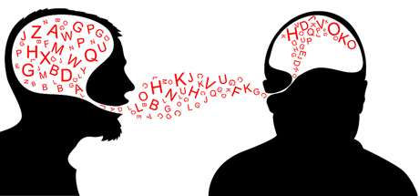
Fluency is the ability to read with speed, accuracy and proper expression. Through elementary school, our goal is get students to this level. The younger of our students will sound choppy and unnatural when they read, but over time, we want them to be able to understand and express the written passages as they read. The amount of reading increases each year they are in school and we need to prepare them for secondary school. As ESL teachers, we have to be aware that students are often making two levels of conversion when reading. First, they might convert the alphabet into words and then convert those words into their native language. As their English levels increase, some students will be able to understand the text in English without converting to Korean in their head. However, this may not be the case in your classroom. Students may just be struggling with sounding out the words at the beginning of their education and have trouble expressing the texts towards graduating from elementary school.
Fluency relies heavily on mastering the skills we already examined; oral language, phonemic awareness, and phonics. Students that have difficulty in these areas will also have issues with fluency, so we may need to spend extra time with decoding words. It is also helpful for students to trace the words as you read aloud and then repeat it back. Providing a model for how a text is to be read is extremely important for fluency in reading. It shows the students how to express the text and proper pronunciation and flow. Another technique you may want to try is having the students read a text with different feelings to add emotion to stories. It may also be helpful to teach student explicitly about punctuation and how to change their voice accordingly.
Along with modelling good oral reading skills, there are other things we can do as teachers to help our students become fluent readers. Encouraging students to ‘read like talking’ is one way for the students to understand how fluency works. Try not to push for speed until the students have mastered accuracy. Choose large print books and easy to read materials so students can follow along with your reading. Have students repeat what you have read with the same intonation.
As students progress, we can add choral reading, cloze reading, partner reading, and reading theater. In choral reading, the teacher and students read together following the pace and imitating the intonation of the teacher. The teacher can also stop the reading at any time to make corrections, identify vocabulary words, make comments or ask questions about the text. Choral reading has the benefit of allowing lower level students to follow along while the rest of the students imitate the teacher. The hope is that these students will benefit from this over other techniques, like independent silent reading, where the student would fall further behind. Through the year, a combination of these techniques can be useful in developing fluency.
In cloze reading, the teacher reads the text, while the students follow along. Occasionally the teacher will stop and it is the students’ job to read the missing word. With the use of PowerPoint, it is easy to cover the word and have the students guess what word would fit. Cloze reading can also be an alternative to partner reading if the activity requires more supervision and correction.
In partner reading, one student reads to another student. Choosing good pairings is important here. Most teachers want to pair high and low level students together. Try to make sure the difference isn’t so large as to make students uncomfortable or feel embarrassed about reading. Students should also be equipped with the skills to make corrections and provide feedback before starting these activities. You can provide a list of things to watch out for during the reading. If a student wants to practice reading at home, but they don’t have a partner, a stuff animal can also take it’s place.
With reading theater, students are given parts to a story to read aloud. Each student will get a separate part. These parts might be paragraphs, pages, or character dialogue. Reading theater might also include poetry readings and acting. It gives the individual student more responsibility for a smaller selection of readings. However, they have the opportunity to master their section. Students are incentivized to add emotion and intonation to their reading.
Vocabulary knowledge is another important skill for students to develop. Knowing the individual words is a key step in understanding the passage. In a more general sense, there are two types of vocabularies. Oral vocabulary is the set of words that a student knows through sound while reading vocabulary is made of the words that a student can recognize in print. If you haven’t made the connection yet, oral language skill is a heavy influence on reading vocabulary. Phonics also plays a large part in vocabulary. Readers have more difficulty in reading words that are not already part of their oral vocabulary. Phonics can help them sound out new words, but vocabulary knowledge allows students to make sense of these words.
For native speakers, most vocabulary words are learned indirectly. Words are more often heard or read outside of the classroom in everyday situations. Children may learn new words in conversation, while being read stories at home, reading extensively on their own or through watching television programs. ESL students can also gain vocabulary in this way as well. Context plays a large role in learning vocabulary indirectly.
However, in the ESL classroom we emphasize direct vocabulary learning. Often the students are not exposed to same situations that would lead a native speaker to learn new vocabulary, so we teach them that vocabulary directly. Teaching vocabulary in this way can be tricky. Before discussing teaching methods for vocabulary, let’s discuss the advantages and disadvantages of when we teach vocabulary. Vocabulary can be taught before a passage, during a passage or after reading a text.
Teaching specific information before reading a text will prime students for what they are going to read about. It will also cause less confusion during the reading. If students are going to engage in independent silent reading, it will give the students a reference when they get to those words in the text. However, spoon-feeding information to students is not always the best way to teach. The words may be more meaningful if they have to acquire the meaning through context.
Teaching vocabulary during reading allows the teacher to address new words as they come up. The students will receive the information at the point that they need to have it. This method can make reading become choppy and interrupt the flow of the story. The overall meaning of the passage might be lost to component parts if you stop often during reading.
Teachers may also choose to address new words after the text has been read. Teacher could prime the students for these words by proving a list of new words that students must watch out for. Students are encouraged to derive meaning by looking at the context the word is in. This more closely resembles the way that native speakers acquire new vocabulary. Students can also ask about the meaning of other words after the text has ended. This method encourages students to think creatively and analytically. Information that is learned this way seems to last longer. This method is best reserved for higher level students or students in higher grades. It may be difficult for elementary students to derive meaning from context. This method also takes longer than the other two.
Teaching vocabulary is part of nearly all lessons in ESL. We are always trying to add what the students already know. We should also be aware that vocabulary isn’t a one-time thing. To put new word in our long term memory and to become fluent with them, we repeated exposure. This is why reviewing previous lessons and having review classes is important for students. Showing a word in various context and over a long period of time will help students understand how to use new vocabulary.
Teaching about prefixes, suffixes, root words, and compound words are a great way to build on vocabulary they already know. It is another way for students to receive repeated exposure in various contexts to these words. Similarly, teaching students about root (or base) words will also help students to make sense of new words that they might encounter.
Here are some common ways to teach vocabulary:
- Direct translation
- Matching words to pictures, translations or meanings
- Guess the missing word
- Presenting new words with visual stimuli (pictures, flashcards, realia)
- Labelling pictures
- Cloze sentences
- Guess the meaning through context
- Relate it to known words (synonyms, antonyms)
- As part of a word cluster
- Mind maps and other diagrams
- Practical English (when a student asks for a word they want to use)
- Elicit information (higher level students will know the answers)
This list might give you some ideas on strategies to teach new vocabulary. But what words should you teach? Be aware that your students might not all be at the same level. Find some words that all the students will know and some that only a few (or none) students might know. Vocabulary is not a time to extract information from lower level students. This is a time to let the keener students show off how much knowledge they have. Try to see this part of a lesson as an opportunity to get students involved and excited about English. Children love learning new and interesting information. If you are teaching vocabulary before a passage, make sure the words will appear in the text. Words important to the understanding of the text should be explored at this time to make sure all of the students are prepared for the text. Difficult words should also be taught. This way your class won’t get hung up on these words. Similarly, unusual words should also be addressed before the reading. Difficult and unusual words along with useful words can be taught outside of reading lessons to increase the student’s vocabulary as well. At higher levels, you can start examining phrases and idioms.

Ultimately the goal of reading is Comprehension. If the students don’t understand what they are reading, it is a waste of time. In this context, comprehension refers to deriving meaning from text.
We can improve the comprehension level of our students by using a few strategies. The National Institute for Literacy (2006) identifies six strategies for improving reading comprehension:
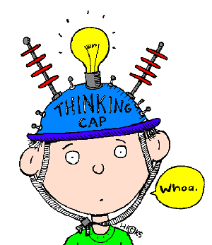
- Monitoring Comprehension – students know if they understand the text or not. They have the ability to ‘fix up’ what they don’t understand by using appropriate strategies including asking the teacher about things they don’t understand.
- Using Graphic and Semantic Organizers – Students use diagrams or other pictorial devices to illustrate relationships and concepts in the text. Graphic organizers include; maps, webs, graphs, charts, frames, or clusters. Semantic organizers, like mind maps, use lines to connect a central concept to related ideas and events.
- Answering Questions – Questions can improve learning by: giving purpose to the reading, focusing attention, making students think while reading, encouraging students to monitor their comprehension, and helping students to review the information they received.
- Generating Questions – Students are asked to make their own questions. This gets students to think about their own understanding and makes them pay more attention in order to create good questions.
- Recognizing Story Structure – Students must recognize and understand how events are arranged into a plot. Student may be asked to identify setting, initiating events, internal reactions, goals, attempts and outcomes.
- Summarizing – Students identify the main or central ideas and reduce the information to the most important parts.
While advanced readers may employ multiple strategies while trying to understand a text, our elementary students will likely rely on asking and answering questions. These are our main tools for making sure students understand the text. Questions can relate to overall themes or specific information. We should avoid asking, “do you understand?” at all costs. Students will just reply, “yes.” whether they understand or not. A good question will require the students to demonstrate their understanding of the text. It can be difficult to explain good question formulation without an example, so let’s use an example. The following text is from a Grade 6 Elementary School English (2014) textbook:

A Kangaroo and a Kakuru
What does a kangaroo look like? What does a kakuru look like? A kangaroo has big feet and a long tail. It has strong legs. It can jump very well. The kakuru had big feet and a long tail, too. It had strong legs like a kangaroo. It could jump very well, too. The kangaroo lives in Australia. The kakuru lived in Australia, too. Are they brothers?
There are also illustrations of the kangaroo and kakuru with the story. There are a number of different type of comprehension questions you may ask. A question may ask the students to give specific or general information about the text: “What does a kakuru look like?”, “What is the same about a kangaroo and a kakuru?” These questions have definite answers, but the possible answers are not limited to yes and no.
Yes or No questions ask specific information while True or False questions make a statement and students agree or disagree: “Is the kangaroo good at jumping?” “The kakuru had a long tail. True or False?” These questions are easier and great as warm ups, but they don’t show whether students really understand the text. After all they have a 50% chance of guessing the answer. The same can be said of multiple choice answers. However, students may show more knowledge when answering a multiple choice question as the possibilities are more nuanced.
You can also check comprehension my having the students make marks in the text. “Circle the things that are similar between the two animals.” With these questions, the students are encouraged to go back through the text to search for information. This also gives the students a chance to reread the text with more accuracy. You can ask for similarities, differences, specific information, key words, new words, the answer to other questions, etc.
Open ended questions and statements can be used to elicit information from students as well. “Think of a family member or friend. What do they look like?” “A tiger has…” With these questions, students must use English creatively. These questions may be difficult for our students, but we can certainly help them through it. These types of questions not only help with comprehension, but also make the information applicable.
List questions will provide a list of possible answers and ask for the one that is different. This might be in the form of a correct answer or the only incorrect statement. Students might also be asked to identify what the list belongs to or to put the information in order. Cloze sentences, labeling, chose the word that fits, and ‘why is this statement wrong?’ are just a few more examples of types of questions you might ask to test comprehension.
Comprehension will increase with fluency and vocabulary knowledge. As students get older, we should teach these strategies to students to help them later in their educational careers. These strategies will not only help them understand English but also their native tongue, Korean.

A Reading Lesson
Pre-Reading
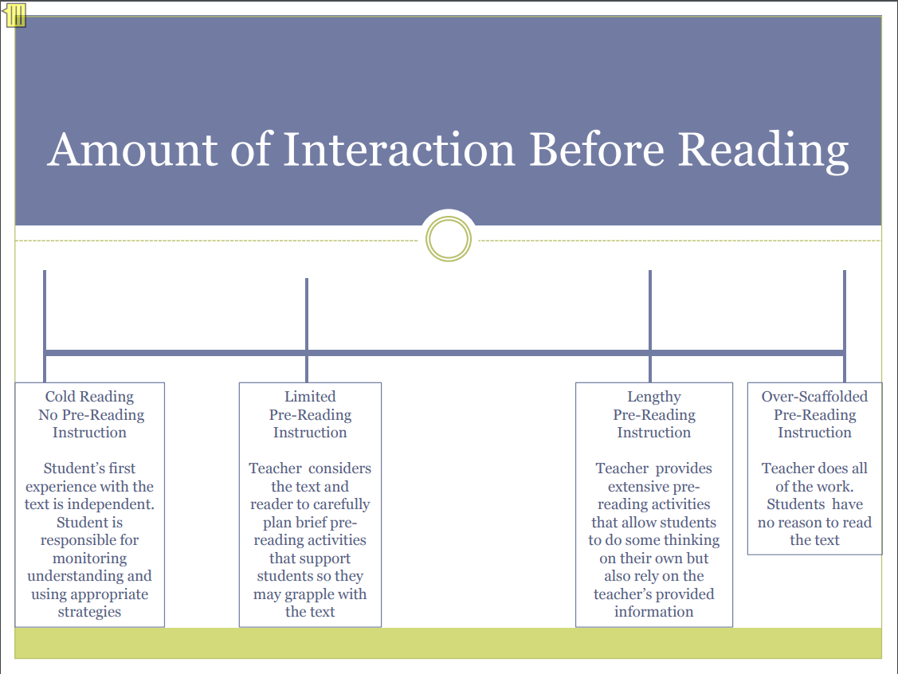
http://www.ride.ri.gov/Portals/0/Uploads/Documents/Common-Core/Pre-Reading-PowerPoint.pdf

A typical reading lesson follows the pretest-text-test format. However, I am a fan of warm up – pre-read - teacher read - test - students read – review. A warm up can be anything related to the subject matter of the text, but I will be skipping that part here. Warm up activities and pre-reading activities often overlap. A Pre-reading activities rely on general knowledge. The idea with pre-reading is to get the students thinking about what they are going to read. Listed below are some ideas that you can try with your students.
Pre-Reading questions are a very common way to elicit prior knowledge and to prepare the students for the text. For example, if you are going to read a passage about baseball, why not ask the students what their favorite sport is? Depending on the level of your students you can ask them how they feel about the topic. You could have the students try to guess the subject of the article by playing 20 questions. Another idea is to make a quiz about the article’s subject. Alternatively, you could make a quiz about the text. Have the students answer this quiz before reading the text and after to see how their answers changed. Another common pre-reading activity is getting the students to guess the subject of the article based on the title. Finally, you could also have your students guess the subject or what will happen by giving them some key phrases or quotes from the passage. Quotes can also be given out of context and have the students guess how the story will progress to that quote or why the character might have said it.
As discussed above, this is a good time to introduce vocabulary. As we saw in the last section, vocabulary is one of the essential skills for reading. By increasing their vocabulary with words they will see in the text, students will be better prepared for what they are going to read. This will cause less confusion during the reading and allow things to proceed easier. As vocabulary has already been discussed, I will move on to another pre-reading activity.
Brainstorming is another pre-reading activity that is commonly practiced. This is a great way of eliciting prior knowledge from students to prepare them for the text. If the text is about a common group of items (animals, rooms in a house, places), have the students make a list of items they know from that list. You can make brainstorming more fun by having the students work in pairs, groups or as a class because group knowledge is always better than individual knowledge. One activity I enjoy doing with students is having them brainstorm and write down a list (for example animals). Then, the students tell the class what they wrote, if two groups have the same answer (group A says “lion” and group B also wrote it) they must cross it out (neither team A or B gets points for “lion”). Alternatively, you can generate your own list before class and any matching answers will get points for the students. In regards to animals, I made my own ‘zoo’ and any animal that they guess was in my zoo got one point. If you decide to generate your own list, have some answers that all the students will get and some that might be new for the students.
Another brainstorming type of activity is to give the students a list of words and have the students categorize them. This may also require some vocabulary introduction before starting this activity. You can also use a generated list of words in other ways. Try having your students put a list in order. This can be alphabetical, chronological, when they will appear in the text, numerical, or even order of importance to the students. For example, if the text is about daily routines, give the students a list of chores and have them put it in the order that they would do them on a regular day. Mind maps and word clouds are other types of brainstorming activities you may want to try.
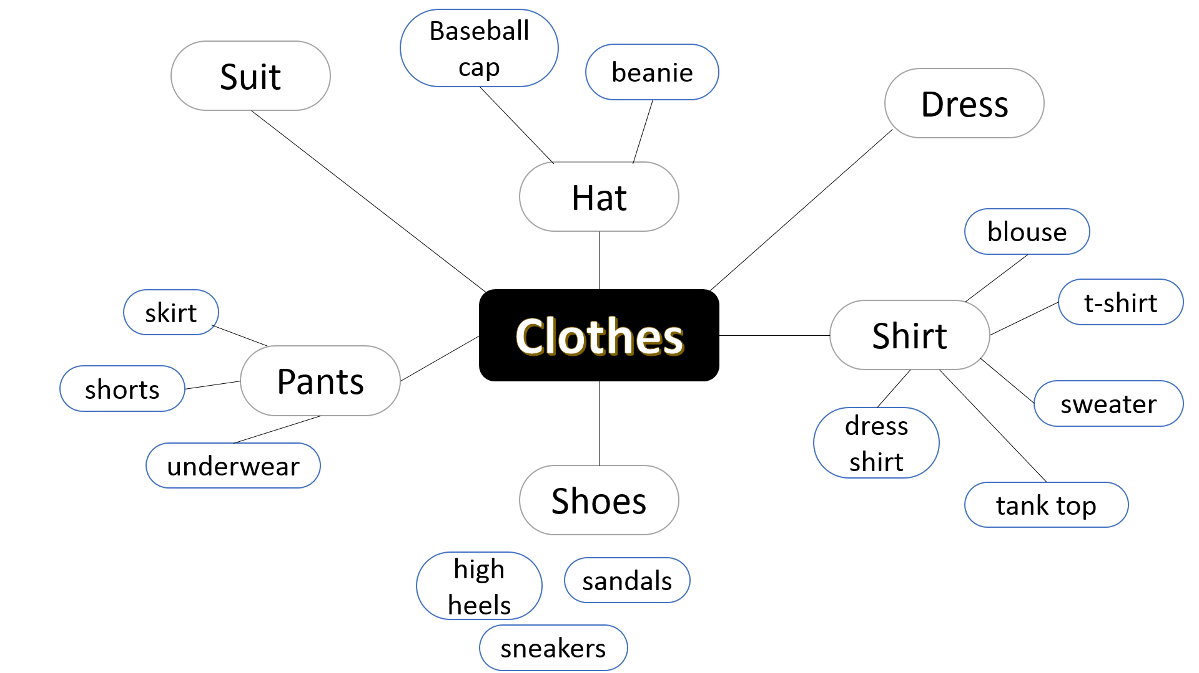
Another common pre-reading activity is skimming. This requires the students to have been taught the skimming skill before the lesson. Students are given a short period of time to look over the text to identify key words, themes, general impressions or to identify main plot elements. After skimming, students may be asked what they think the text is about, or to make a title for the article. Teachers may also have students skim the text for new or unfamiliar words. This will allow the teacher to address the words that the students will struggle with before reading. Finally, the students can use the information they received during skimming to predict what will happen in the text. They may be able to identify the purpose of the article and how it might relate to them.
Pictures can also be used for pre-reading activities. Pictures may also be used to explain new vocabulary but they can also be used for other activities. One way to use pictures is to show pictures of the main characters or items from the story. The students can try to guess how they relate to each other and predict what will happen using those picture clues. Most of the texts we use in the elementary classroom are illustrated. Using a scanner, you can use these illustrations. A good activity is to take a few of the most important pages from the book and have the students predict the order of those pages. Basically, you are asking the students to create a story board from picture clues. This activity also works for during reading as the students can check their own work the book is read.
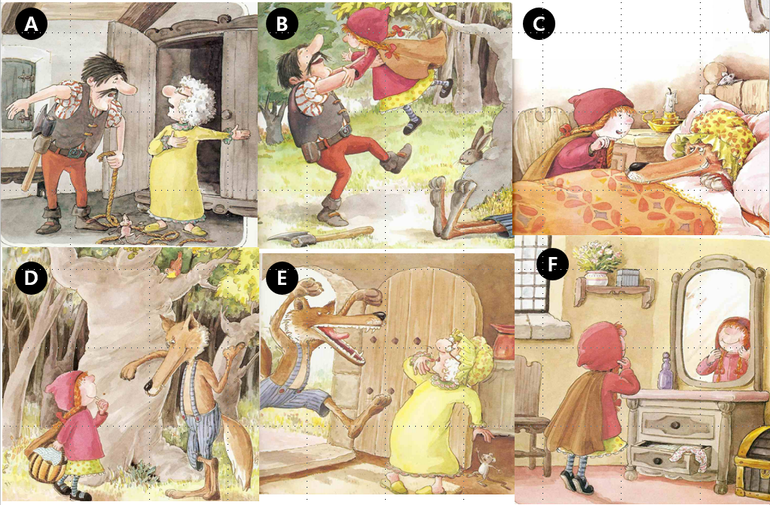
Can you put this story board in the correct order?

Teacher Read
It is good for students learning a second language to have that language modeled for them before going into a deeper reading. This is especially true for elementary students. Students will have the opportunity to hear what the text should sound like from the teacher. This helps the students in many ways. Some students may not have developed their phonics skills, so they will benefit by following along and seeing how the text is pronounced. Auditory learners will also be able to access the information in the text without having to extract it from only the written words. Students are not required to extract all of the information in one reading. When the teacher reads, they can focus on emotion and a general idea about what is happening in the story. A good teacher will exaggerate intonations and use body gestures to help explain the story. It’s also easier for the teacher to stop the reading to address any questions that the students have. Finally, the teacher can regulate the pace of the story to help the students understand the passage. For these reasons I try to model each passage before requesting that the students read it.
Robert Munsch is a Canadian children’s book author.
In class we will watch a video of him telling a story (youtube.com/watch?v=nSY1kGtqkt0) . He is an excellent
storyteller. He offers the following advice:
- Be crazy
- Use strange voice
- Involve your children
There are some activities to involve the students during this part of the lesson. It is important to keep the children interested while you are reading. The most common strategy is to give the students a set of questions to answer while the story is going. Similarly, putting sentences or pictures in the correct order while listening to the story can also keep the students engaged.
Another interesting strategy to get students involved is to give them something to do during the reading. Maybe they need to count the number of times key words come up, or cross off the words as you read them. They can follow along with their finger or repeat the sentences as you read them. The teacher can also ask predictive questions as they read keeping students engaged and increasing comprehension. You can also get the students to perform actions while you read the passage. Students can make dramatic hand gestures or act out certain words as the teacher reads the story. If you are having trouble picturing what this might look like, I highly recommend the video by Chris Biffle, “Crazy Professor Reading Game.” You can find his video on YouTube (https://www.youtube.com/watch?v=8xFcUPQ_z_8).

Test
Don’t be afraid. We are not going to give the students a test every class. Instead this section is more about checking understanding than it is about testing the students. However, the questions do test comprehension or the read text. This is an important step for identifying areas of misunderstanding and to clear them up before the students have to read the passage. Questions should be phrased to check that students understood the meaning and move towards questions that are more specific. Good questions relate to the main theme of the story, the feelings of the characters, important plot points and key phrases addressed in the pre-reading section of the lesson. For lower level students, yes/no questions are less intimidating (Did Sangmin catch the fish?). Higher level students might enjoy more open ended questions (Why didn’t Sangmin not catch the fish?). Whatever you do, don’t ask, “Do you understand?” Try to have a few different levels of questions, so the lower level student can have an opportunity to contribute as well as the higher level students.
In addition to asking questions, you can also have students compile the information they received in the form of lists or matching activities. If the students had a task to do while the teacher was reading, this is the best time to check that. Taking up the answers to the teacher reading activities can replace or supplement the comprehension check questions. This is a good time to use BHH reading questions. BHH stands for Book-Head-Heart.
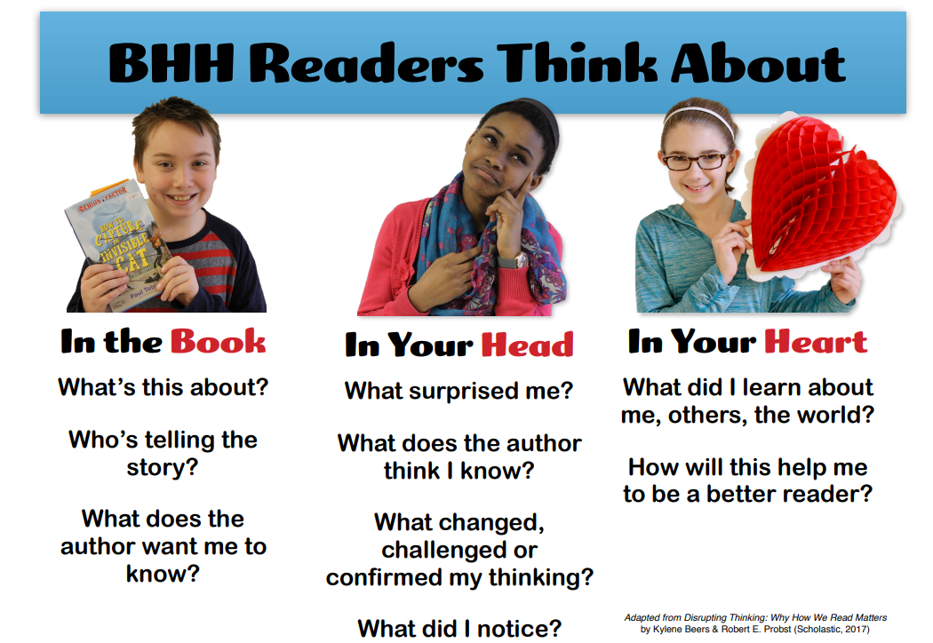
https://www.scholastic.com/content/dam/teachers/blogs/mary-blow/2017/MB-BHH-7-Poster.pdf
Finally, this is the best time to address any questions that the students might have. If there are any words that the students did not understand, writing them on the board and explaining them is valuable. If the questions you asked didn’t help the students to understand text, this is the time to help the students. In extreme cases, a teacher may choose to go over the text slowly with the class and explain what is happening page by page. If you find yourself in this situation, try using other pre-reading activities.

Student Read
Student reading can take many different forms. These include silent independent reading, partner reading, buddy reading, round robbin reading, class theater, and choral reading. Each form has its own pros and cons. I will briefly explain the different forms of student reading and discuss their advantages, disadvantages and offer any advice I can on how to use those forms more effectively.
In silent independent reading, the students will read the text alone. This is great for class management as your students will be quiet and unruly students are easily identified. Students are also allowed to read at their own pace. The teacher also benefits by having time to prepare a review activity, circulate around the room, and address questions that the students have or read as well to model good behavior.
If you are going to use this form of reading, you need to have a way to know when student have finished reading. When a student finishes the text, they can lay their head on the desk, turn over the page or put up their hand. Students who finish early may also start the post reading activity when they finish reading. While some students respond well to silent independent reading, other students may not. For some, the text will be too difficult and you need to help them. Other students will benefit from a more active classroom. It is good to use a mix of reading styles throughout the year.
Silent independent reading works best when students are interested in the subject matter. The reasons why sustained silent reading (SSR) is so effective is because the student choose material that they are interested in. When teaching from a syllabus, students have a limited choice of material. It may be beneficial to give the reading a purpose. You can make the students aware of the review activity to motivate them to read. For example, if the review activity is to write a postcard to a parent about the story, they may be more motivated to search for understanding and nuance in the story to make their postcard more interesting.
Partner reading is as it sounds. Students take turns reading to each other. Before reading, the teacher will explain the section length (paragraph, page, sentence). When a student finishes their section, the other student reads. Students benefit by having a friend help them through the reading. They wouldn’t have that opportunity in independent reading. They also may feel more comfortable reading aloud with a small audience. Asking a student to read in front of the class might cause anxiety whereas partner reading is less stressful. When using this activity, you might notice that students are much more expressive and take more chances with their English in this atmosphere.
The biggest concern with this form of reading is classroom management. Half of the students are talking all at the same time. It is difficult, but not impossible for the teacher to keep all students on track. Getting help from the teacher may also be more difficult for the students and some problems, like mispronunciation, may go unchecked. Students may get distracted as well. It is difficult for a single teacher to make sure all of the students are on track, so some students may take the opportunity to chat with their friend until the teacher walks near them.
To keep things organized, you can include a talking stick. It can be any object, not just a stick. Whoever is holding the talking stick gets to read. This helps the students know when it is their turn to talk. It also helps the teacher keep an eye on the class. Any group that is not passing the stick consistently might be having trouble with the text. Encourage students ask comprehension check questions as the other reads. The students can work through the issue together or ask the teacher if they are really stuck. Another way to make this style of reading more interesting is by changing when the students take turns. You may use a timer, or a bell to indicate to students that the other one gets to read.
Buddy reading is similar to partner reading. In this form of reading, a student of a higher level will read to a student of a lower level. Usually a student will read a story to student in a lower grade. Because this is so rare in the ESL classroom, I will not address it here, but I wanted you to be aware of it.
In round robbin reading (RRR), students take turns reading from the text. This is a very common practice in the ESL classroom even though students aren’t too interested in doing it. Popcorn reading, combat reading, popsicle reading and touch-and-go reading are very similar. Finley (2004) does a great job explaining these:
- Popcorn Reading: A student reads orally for a time, and then calls out "popcorn" before selecting another student in class to read.
- Combat Reading: A kid nominates a classmate to read in the attempt to catch a peer off task, explains Gwynne Ash and Melanie Kuhn in their chapter of Fluency Instruction: Research-Based Best Practices.
- Popsicle Stick Reading: Student names are written on Popsicle sticks and placed in a can. The learner whose name is drawn reads next.
- Touch Go Reading: As described by Professor Cecile Somme, the instructor taps a child when it's his or her turn to read.
There is a reason why it is a popular method of student reading. It requires little preparation for the teacher, it is familiar and simple. Teachers are also able to correct the students in real time. As far as classroom management is concerned, this is an effective way to keep the class under control. Unfortunately, there is little evidence to suggest that this method is effective. Students may feel uncomfortable speaking alone in front of the class. In addition to embarrassing low lever readers, you also run the risk of students picking up bad habits from them. Fluency and comprehension are hurt by breaking between speaking parts and the different styles of reading. These disadvantages can be minimalized by having the students read in groups. Overall, RRR is not the best reading strategy.
Class theater takes some of the qualities of RRR, but presents them in a better way. Students volunteer, or are selected to have different roles in the reading. This method works very well with dialogue reading. Students take on the roles of different characters. It is good to add in small parts for lower level students, so they can join in the fun. The rest of the class can join in, cheer as an audience, or take on the role of a group of people. For example, after Kevin scores a goal, the rest of the class can clap and cheer.
Students are more invested in the story as they get to choose their own roles. They will become experts on their role and will want to be more expressive. This is a great opportunity to teach fluency skills. In a good class, this type of activity will encourage students to participate and to learn more so they feel comfortable in participating. This method is especially effective for tactile learners and those that need a lot of stimulation when learning. The language is more real when they are also acting it.
Some students or classes may be shy and not want to participate. For those classes, English may become a scary time where they have to act. Some students are just uncomfortable like that. Younger students respond to this type of reading a lot better than older students. As students progress through elementary school, they are less excited about role play and activities like that.
Class theater is very similar to role play, so why not must make the reading into ta role play activity. You can have the class split into groups and choose roles. You can also add props and costumes to the reading. If you are turning it into a role play activity, try to give students time to practice their lines. You can also allow students to change the dialogue a bit. Try to get them to use the key phrases for the lesson. Role play can also be used as a review activity after using another form of student reading if you wish. In active classes, you may need to do this type of a reading a few times to allow more students to participate.
Choral reading involves the whole class. The students all read the text at the same time with the teacher. With this type of reading, students won’t feel uncomfortable when reading because their voice can be absorbed by the chorus. If they make a mistake, it is unlikely that the other students will hear the mistake. Unfortunately, the teacher won’t be able to hear the mistake either. This type of reading relies on the student making their own corrections by following the model of the rest of the class.
You can make choral reading a little more interesting and increase fluency by adding emotion to the story. Students will reflect your emotions and intonation as you read. You can even add gestures that the students can copy.

Review Activities
Review activities should check any comprehension issues the students had during the Test part of the lesson. Review activities are best when they apply the knowledge learned in the text. This is a great time to explicitly delve into the key phrases and words of the lesson. There are many games and activities that can be done at this time. As we have mentioned already, these activities might include storyboards, writing postcards, or creating a role play. Keep in mind that the best activities are ones that are unique to the text. Finding activities on a passage by passage basis will be more interesting. Listed below are some general games you can try to review reading. It must be stressed that the best games are customized to the text.

Illustrate It – Students draw a picture about some aspect of the passage. Ask the students to explain their pictures. What is happening in the picture? Why did you decide to include that in your picture?
Advertise – Students can make billboards, posters or create skits about the article they read.
Word Games – Word searches and crosswords are familiar to the students and allow the teacher to address key words and phrases.
Quizzes and Questions – This is an easy way to review the text. Try to make the questions more specific than in the Test part of the lesson. You may also let students refer to the text for answers.
Reconstruction – The students must try to put the story back together. You can give them sentences paragraphs or just let them write. This is best done in groups.
Rewrite – Students can change words or sentence, but keep the key phrases in. With graphic novels and comic books, you can blank out what the characters are saying and let the students fill in new dialogue.
Dear Author – Students can write a review of the text, ask questions and make suggestions to the ‘author’. As the teacher, you can read these. They will help you choose future passages.
Interview a Character – One student (or teacher) will act as a character from the passage. The other student will ask why they did some things and their motivation.
Jigsaw – Students gather in groups to discuss different aspects of the text. After some time, they form new groups and share the information from their previous group.
What Would You Do? – Students can discuss how they would have acted in story if they were the main character.
Debate – If something controversial came up in the text, you can have the students offer their opinions. You can also make a pros and cons list.
Find It – If all of the students have the same text, have them race to find key words, phrases, or answers to questions.

Other Reading Activities
In addition to using books, articles and passages to develop reading skills, there are a number of games and activities that rely on reading. I will discuss some of these.
In sleeping elephant, students work in groups. All of the students close their eyes and put their heads on the desk (got to sleep). Show part of a sentence or dialogue. Tell elephant number one to wake up (open your eyes). They can see the written text. Depending on level, you can have the students write this information down or try to memorize it. Elephant 1 goes back to sleep, change the information and have elephant 2 wake up. Repeat until the group has all of the information. Finally, the group must work together to reconstruct the text.
Concentration is the game where all of the cards are facing down. One student picks up two cards. If they are the same, they keep them. If they are different, the return the cards facedown. The player with the most cards at the end is the winner. This is a great way for students to recognize spelling. You can also have students match words to pictures, synonyms or definitions.
If you have a very active class (as younger classes tend to be) you can try word relay. In this game, students work in a group to reconstruct a text. Usually one student from each group will run to the teacher to get information to share with the group. However, you can modify this game. You can have partial texts written around the classroom that students need to run to. If you are comfortable with a hectic class, you can have all of the students running around finding information at the same time. Another form of this game has info graphs or information sheets around the classroom. Students must go around the room and gather information from these texts to complete a worksheet.
If you are teaching about imperative sentences, you can try making a treasure hunt. Students are given a starting clue (The next clue is in a book about New York) that will lead them to the next clue. They continue finding clues until the ultimately find the last clue. When you are making the game, I suggest that you start with the last clue and work your way back to the start. This activity works best in small groups or a larger area. You may also want to tape down the clues so students leave them for the next group.
Another great activity for directions is to make something. Students must follow written directions. The reward is what they make. This can be as simple as drawing a picture to putting a robot together. Baking class is a great example of this activity in practice.
You can also assign role and give secret information to students in games like Murder Mystery. When I play games like this in my classes, I usually change it from murder to stealing. Students need to interrogate the witnesses to find the thief. Finding appropriate material for the ESL classroom might be difficult, but you can try some that I made (http://www.esltoybox.com/?page_id=546 – “Vacation Liar”).
Finally I’d like to mention flip teaching here. In flip teaching, students are responsible for teaching materials to other students. Essentially they are becoming the teachers. I find the best way to do this is by forming groups. Each group gets a different text or part of a text. Together the group must read and research it. This usually take a whole class. In the next class, the students split their groups to form new groups. They teach each other about the material like the jigsaw activity. Instead of doing the jigsaw activity, you can have the students make presentations and / or posters about their text.

Conclusion
Reading is an extremely important part of English education. Finding appropriate material for students can be difficult but rewarding. I hope that I have presented some good sources for material and provided you with games and activity ideas. As teachers, we have the task of not only teaching reading, but six essential reading skills: oral language, phonemic awareness, phonics, fluency, vocabulary knowledge, and comprehension. This article discussed the basics of these skills and offered ideas on how to teach these skills to students. We also looked at my preferred way of teaching a reading lesson. First, I like to start with a warm up and / or pre-reading activity. Then the teacher reads with follow up questions, the test. After that, the students have a chance to read before doing a review activity. There are many ways to have students read, and we discussed some here. Finally, we looked at some other reading activities that you can do with your students.
Attached below are some worksheets and activities that we will use during class. They are presented here so you can use them in your classroom.

References and Additional Resources:

ABC Life Literacy Canada (2012). Robert Munch Shares His Story Telling Tips. [video] Available at: https://www.youtube.com/watch?v=gYgtouATi7I
Araujo, Judith E. (2012). Phonemic Awareness for PreK, K, and 1. [online] Available at: http://www.mrsjudyaraujo.com/phonemic-awareness-for-prek-k-and-1/
Biffle, Chris (2007). Whole Brain Teaching: 4th Grade: The Crazy Professor Reading Game. [video] available at: https://www.youtube.com/watch?v=8xFcUPQ_z_8
Burke, Jim (Accessed 2018). 103 Things to Do Before, During, or After Reading. [online] Available at: http://webcache.googleusercontent.com/search?q=cache:http://www.readingrockets.org/article/103-things-do-during-or-after-reading
Choi, Hee-Kyeong. (2014). What Does She Look Like In: Elementary School English 6. YBM, 52-53.
Finley, Todd (2014). 11 Alternatives to “Round Robin” (and “Popcorn”) Reading. [online] Available at: https://www.edutopia.org/blog/alternatives-to-round-robin-reading-todd-finley
Hasbrouck, Jan (Accessed 2018). Developing Fluent Readers. [online] Available at: http://www.readingrockets.org/article/developing-fluent-readers
International Reading Association (1998). Phonemic Awareness and the Teaching of Reading: A Position Statement from the Board of Directors of the International Reading Association. [pdf] Available at: https://www.literacyworldwide.org/docs/default-source/where-we-stand/phonemic-awareness-position-statement.pdf?sfvrsn=944ea18e_6
Konza, Deslea (2014). Teaching Reading: Why the “Fab Five” should be the “Big Six”. Australian Journal of Teacher Education, [online] Volume 39(12), p.152-169. Available at: https://docs.wixstatic.com/ugd/10c76b_604c70ad852847c2b46167941169506f.pdf
Lewis, Miss Emma (2018). Research Behind the Big Six – Why are these known to be the ‘essential elements’, when teaching students to read, in English? [online] Available at: https://www.bigsixreading.org/the-six-skills-teaching-framework?fbclid=IwAR0t1N_-rq6NKeEIAIg4QHSu6vnKJMh9lzNwQ-eozOIHS0k_AA8_r934wp8
Lewis, Miss Emma (2018). Phonemic Awareness. [online] Available at: https://www.bigsixreading.org/phonemic-awareness?fbclid=IwAR1R6JnGofSq-s5kFrfOjr2iC-KU6c9kpJtijd9E1Oh_LwgWjUuwKxcXoBs
National Institute for Literacy (Accessed 2018). Put Reading First. 3rd Ed. [pdf] Available at: https://lincs.ed.gov/publications/pdf/PRFbooklet.pdf
National Inquiry into the Teaching of Literacy (2005). Teaching Reading – Report and Recommendations. [pdf] Available at: https://docs.wixstatic.com/ugd/10c76b_dc7cb1b689a5435eafce0f68c3f3fa53.pdf
National Reading Panel (Accessed 2018). National Reading Panel – Teaching Children to Read: An Evidence Based Assessment of the Scientific Research Literature on Reading and Its Implications for Reading Instruction. [pdf] Available at: https://docs.wixstatic.com/ugd/10c76b_dc7cb1b689a5435eafce0f68c3f3fa53.pdf
Newman, David (2018). Sounds to Graphemes Guide. [pdf] Available at: http://www.speechlanguage-resources.com/support-files/soundstographemesguide2.pdf
Pesce, Claudia (2018). 7 Essential Reading Strategies Your ESL Students Must Know (and You Must Teach). [online] Available at: https://busyteacher.org/15985-7-must-know-reading-strategies-esl-students.html
Rhode Island Department of Education (Accessed 2018). Pre-Reading Strategies and the Common Core State Standards. [pdf] Available at: http://www.ride.ri.gov/Portals/0/Uploads/Documents/Common-Core/Pre-Reading-PowerPoint.pdf
The ESL Toybox (Accessed 2018). Lesson 12 – Why Are You Upset? [online] Available at: http://www.esltoybox.com/?page_id=546

