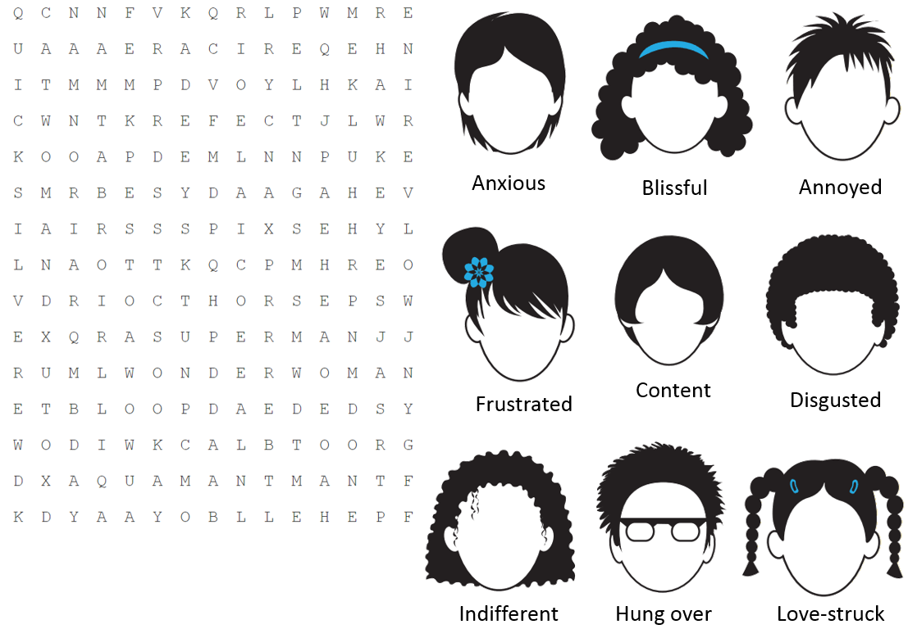

Headbangers
Woodpeckers spend their days banging their heads against trees. So why don’t they get headaches? Research has shown that the impact of a woodpecker’s brain against its skull is spread over a relativity large surface area. This makes the vulnerability of a woodpecker’s brain to injury very slight compared to that of a human brain. Furthermore, a woodpecker’s brain fits tightly inside its skull. This allows for hardly any movement, and there is little risk of injury. A woodpecker’s brain is also protected by the concentration of each impact on the areas of the skull that are the thickest. Consequently, much of the force that the woodpecker experiences is absorbed by its thick neck muscles rather than its brain.

- What animal are they talking about?
- What do the woodpeckers do all day?
- What body part is special on a woodpecker?
- Why does it need a special brain?
- What muscles absorb the impact?
- [True or False] Its brain hits the skull.
- [True or False] Its brain fits loosely in the skull.
- [True or False] The force of the impact is on the thickest part of the skull.
- Underline the adaptations of the woodpecker.
- List the ways that the woodpecker is protected when it hits its head.

- The woodpecker has evolved to…
- It can do this because…
- I think the woodpecker shouldn’t hit its head against the tree. Do you agree or disagree? Why?
- Why can’t humans hit their head against a tree?
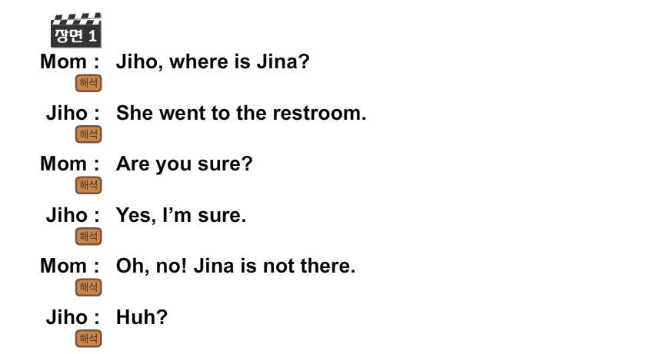
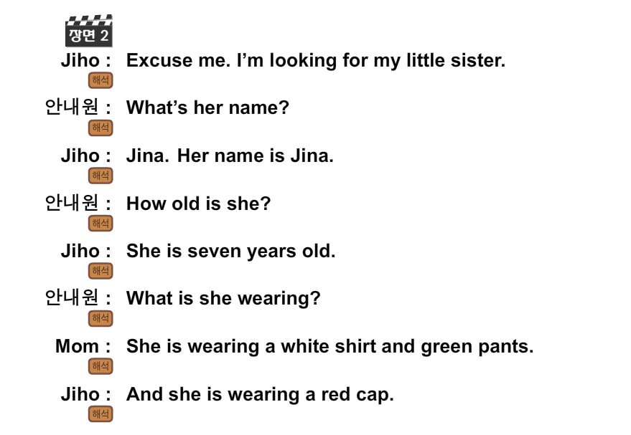

The Pale Blue Dot
Consider again at that dot. That's here. That's home. That's us. On it everyone you love, everyone you know, everyone you ever heard of, every human being who ever was, lived out their lives. The aggregate of our joy and suffering, thousands of confident religions, ideologies, and economic doctrines, every hunter and forager, every hero and coward, every creator and destroyer of civilization, every king and peasant, every young couple in love, every mother and father, hopeful child, inventor and explorer, every teacher of morals, every corrupt politician, every "superstar," every "supreme leader," every saint and sinner in the history of our species lived there--on a mote of dust suspended in a sunbeam.
The Earth is a very small stage in a vast cosmic arena. Think of the rivers of blood spilled by all those generals and emperors so that, in glory and triumph, they could become the momentary masters of a fraction of a dot. Think of the endless cruelties visited by the inhabitants of one corner of this pixel on the scarcely distinguishable inhabitants of some other corner, how frequent their misunderstandings, how eager they are to kill one another, how fervent their hatreds.
Our posturing, our imagined self-importance, the delusion that we have some privileged position in the Universe, are challenged by this point of pale light. Our planet is a lonely speck in the great enveloping cosmic dark. In our obscurity, in all this vastness, there is no hint that help will come from elsewhere to save us from ourselves.
The Earth is the only world known so far to harbor life. There is nowhere else, at least in the near future, to which our species could migrate. Visit, yes. Settle, not yet. Like it or not, for the moment the Earth is where we make our stand.
It has been said that astronomy is a humbling and character-building experience. There is perhaps no better demonstration of the folly of human conceits than this distant image of our tiny world. To me, it underscores our responsibility to deal more kindly with one another, and to preserve and cherish the pale blue dot, the only home we've ever known.

-- Carl Sagan, Pale Blue Dot, 1994
The Year 2019 Will be the Best Ever
Despite all the bad and often depressing news that filled our televisions, newspapers, radios and news feeds in 2018, there are reports that the year 2019 will be the best ever. Breaking News English reporters say it will be a particularly good year for students of English. The reporters say the year will provide ample opportunities to refine and develop your listening, speaking, reading and writing skills. The New Year's resolution of all learners of English and other languages should be to exploit the myriad of websites dedicated to language learning. Dedicating just 30 minutes a day will reap great rewards in developing vocabulary, fluency and comprehension skills.
There are other reasons why 2019 will prove to be the best year ever. However, we all need to pull together and treat each other with love and respect. This year will be the year of good deeds and of helping those who are less fortunate than ourselves. It will also be a fantastic year for hobbies. Reporters say the stars in the sky are aligning to send positive vibes so that we all excel in our hobbies - both existing and new. Financially, we all need to tighten our belts so we can weather whatever monetary storms the year might throw up. And finally, we will all be more health conscious and take better care of ourselves. Reporters urge us all to exercise more and eat more nutritious food.

Ample (adj): generous or more than adequate in size, scope or capacity.
Conscious (adj): to be concerned or interested.
Dedicate (v): to commit to a goal.
Deed (n): the act of performing. Something that is done.
Depress (v): sadden or discourage.
Fortunate (adj): receiving something good.
Exploit (v): to make productive use of.
Myriad (n): numerous and diverse. Many.
Positive vibes (n): good feelings without reason.
Refine (v): to improve or perfect.
Urge (v): to present, advocate, or demand earnestly or pressingly.

New Year’s Resolution – Plans or goals for the year (usually starting Jan.1)
Reap the Rewards – To benefit (or receive) all the good things from your efforts.
The Stars Align – Everything comes together in a positive way (It feels like it was meant to be or the universe made it happen).
Tighten our belts – Spend less money.
Weather the storm – To deal with (or endure) a bad situation.

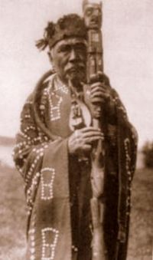
Talking stick
From Wikipedia, the free encyclopedia

The talking stick, also called a speaker's staff,^{[1]} is an instrument of aboriginal democracy used by many tribes, especially those of indigenous peoples of the Northwest Coast in North America. The talking stick may be passed around a group, as multiple people speak in turn, or used only by leaders as a symbol of their authority and right to speak in public.^{[2]}
Akan chiefs in Western Africa have a tradition of speaker's staffs capped with gold-leafed finials. These emerged in the 19th century as a symbol of the holder's power.^{[2]}

Northwest Coast art

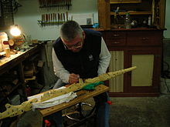
In the Northwest Coast, talking sticks are carved wooden staffs, which can either bear a single crest at the top or be fully carved with heraldic clan crests of the chief or hereditary political spokesman.^{[1]} The staffs can include shell inlay.^{[2]} The staffs resemble small totem poles and are still used ceremonially today.^{[3]} At gatherings, especially potlatches, a chief or his designated speaker holds the talking stick and publicly announces message.^{[3][4]} The speaker thumps the stick on the ground for emphasis.^{[3]} A feather has been used as a stand-in for the talking stick.^{[5]}
Talking sticks are a contemporary Northwest Coast art form with great symbolic importance. Tsimshian woodcarver David A. Boxley was commissioned to sculpt a crown of a talking stick for the 1990 Goodwill Games, that incorporated symbolism of the United States and Russia. This staff was carried from Spokane, Washington to Oregon and on to Seattle, Washington by participating athletes.^{[6]} Talking sticks are also incorporated into totem poles. In 1988 Kwakwaka'wakw Richard Hunt carved the world's largest totem pole featuring a Cedar Man wielding a 4.3 meter (14 foot) tall talking stick.^{[7][8]} Representations of chiefs are carved in totem poles carrying talking sticks as well as coppers.^{[9]}

Senators used a “talking stick” during shutdown negotiations

Sen. Susan Collins’s plan seemed to be working — until one senator reportedly threw the stick forcefully toward another.
By Jen Kirbyjen.kirby@vox.com Updated Jan 23, 2018, 9:29am EST
SHARE
Political pundits will debate the winners and losers of the three-day government shutdown, but a clear frontrunner for the unsung hero award has emerged: Sen. Susan Collins’s “talking stick.”
Republican and Democratic senators reportedly huddled in the office of the Maine Republican senator, who hosted negotiations to break the shutdown stalemate. Collins, in an attempt to keep things civil, borrowed from the kindergarten classroom playbook and came up with the strategy of using a “talking stick,” reports CNN.
Only the senator in possession of the “talking stick” could speak, and his or her colleagues would have to listen until it was their turn with the “ceremonial Native American stick,” as one senator described it to Politico. It was reportedly a gift from Sen. Heidi Heitkamp (D-ND).
“I needed order,” Collins told the New York Times.
And that “talking stick” shtick seemed to be going pretty well — that is, until one senator reportedly flung it toward another, and nearly took out Collins’s office decor. Politico reports:
At one point, Sen. Lamar Alexander of Tennessee forcefully tossed the stick toward Sen. Mark Warner of Virginia after Warner interrupted him, nearly shattering a glass elephant belonging to Collins, according to two people briefed on the throw.
The “talking stick” reportedly chipped the glass elephant after Warner missed Alexander’s toss. “There were no injuries, there were a couple close calls, but everything worked out fine,” a Republican senator told CNN.
Collins reportedly decided to switch to a ball after the dustup, presumably assuming it would be a little less destructive. The next day, “Senator Alexander showed up with a basketball because it’d be safer than a stick,” an aide to Alexander told Vox.
Collins later hailed “the Common Sense Coalition” of 25 bipartisan lawmakers who helped broker the compromise to reopen the government. Whether the “talking stick” had anything to do with their success is just speculation. But one GOP lawmaker did tell CNN that it was “the most entertaining meeting I’ve ever been to.”
Inside Out Script
DAD: Here we go. Alright, open.
JOY: Hmm. This looks new.
FEAR: Do you think it’s safe?
SADNESS: What is it?
DISGUST: Okay, caution! There is a dangerous smell, people. Hold on, what is
that?
JOY: This is Disgust. She basically keeps Riley from being poisoned, physically and socially.
DISGUST: That is not brightly colored or shaped like a dinosaur... Hold on guys... It’s broccoli!
YOUNG RILEY: Yucky! It flies into Dad’s face.
DISGUST: Well, I just saved our lives. Yeah. You're welcome.
DAD: Riley, if you don’t eat your dinner, you’re not going to get any dessert…
ANGER: Wait. Did he just say we couldn’t have dessert?
JOY: That’s Anger. He cares very deeply about things being fair.
ANGER: So that’s how you want to play it, old man? No dessert? Oh, sure, we’ll eat our dinner, right after YOU eat this! GrrrraaaAAHH!!!!
DAD: Hey, Riley, Riley, here comes an airplane!
ANGER: Oh, airplane. We got an airplane, everybody.
DISGUST/FEAR/SADNESS/JOY: Ohh!/Ahh!

Video: https://www.youtube.com/watch?v=k1oXx4delIY

Propaganda Techniques
 | Propaganda | Advertising
Name Calling
Bandwagon
Glittering Generalities
Card Stacking
Plain Folks
Fear
Transfer
Hyperbole
Celebrity Endorsement
Disinformation

Think of an example of propaganda and answer the following:
- Tell us about it:

- What propaganda techniques were used?

- Was / is the propaganda effective?

- If you were to make a propaganda poster for this, what would it say?
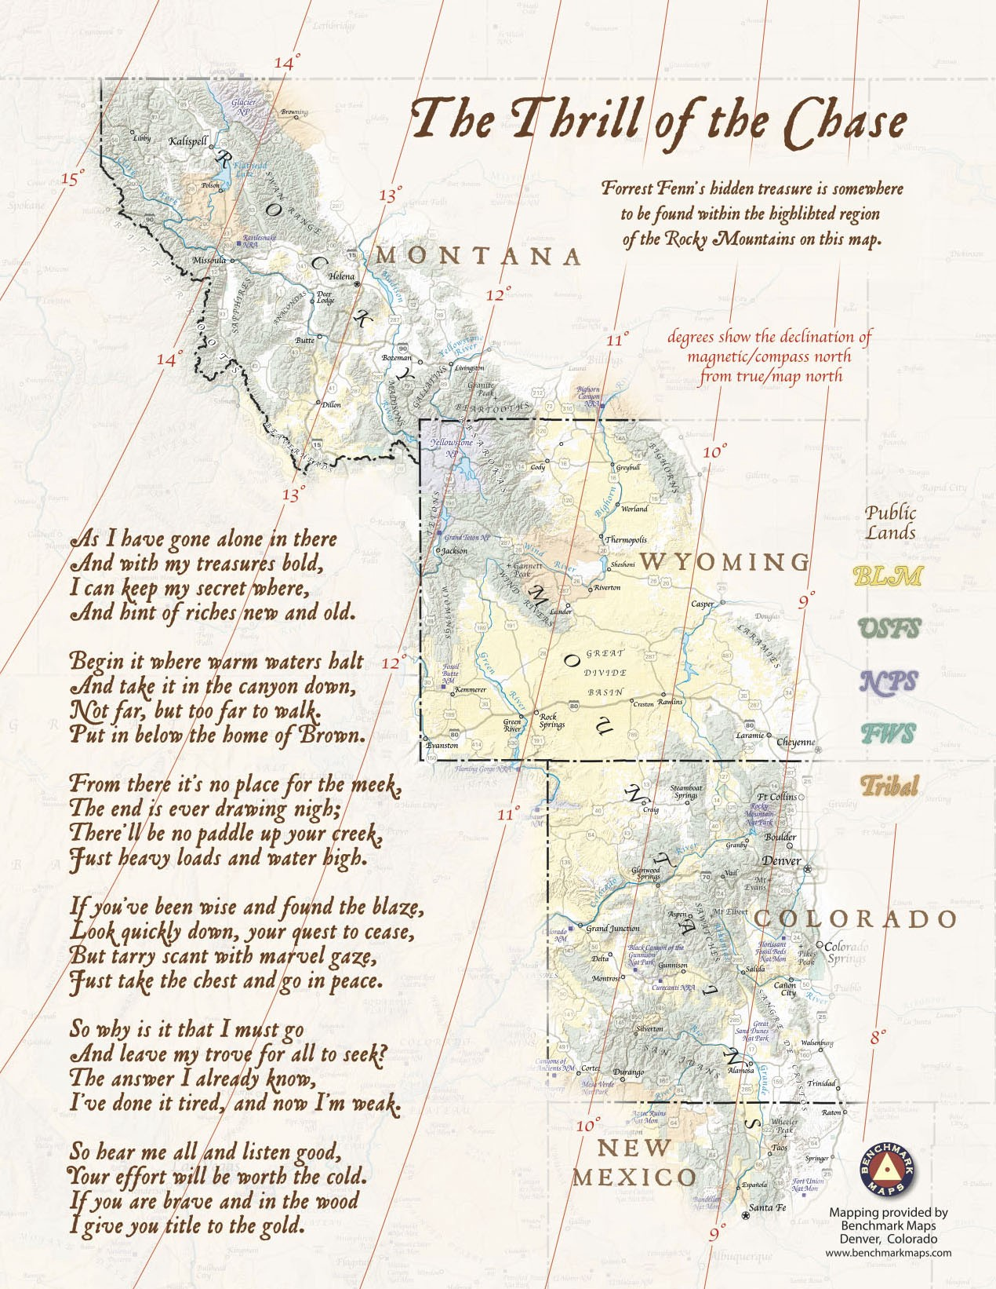

An 87-year-old millionaire buried treasure in the Rockies—and he’s offered one main clue
Yoni Blumberg | @YoniBlum
8:45 AM ET Wed, 18 April 2018
Somewhere in the Rockies, in the roughly 1,000 miles between Santa Fe, New Mexico, and the Canadian border, may be a treasure chest worth millions. The man who claims to have hidden the fortune back in 2010 is Forrest Fenn, now 87, a former Vietnam fighter pilot and art dealer.
Fenn estimates that as many as 350,000 people have gone hunting for the treasure, he tells CNBC Make It, adding that there is no way of knowing whether anyone has actually gotten close. "It could be found soon or 1,000 years from now," he says.
"No one knows where that treasure chest is but me," Fenn told NPR in 2016. That includes his wife. "If I die tomorrow, the knowledge of that location goes in the coffin with me."
The main piece of guidance Fenn has offered is a cryptic 24-line poem he wrote in his self-published memoir, "The Thrill of the Chase." He has since shared the poem on Instagram.
"Begin it where warm waters halt / and take it in the canyon down. / Not far, but too far to walk. / Put in below the home of Brown," reads one stanza.
"Read the clues in my poem over and over and study maps of the Rocky Mountains," Fenn recently told Business Insider. "Try to marry the two. The treasure is out there waiting for the person who can make all the lines cross in the right spot."
The chest is nearly a square foot in size and weighs 40 pounds when full. It supposedly contains emeralds, rubies, gold coins and diamonds — all artifacts that Fenn, a self-taught archaeologist, amassed during his own sometimes controversial explorations in the Southwest, reports Vox. The millionaire was criticized in the 1990s for excavating the San Lazaro Pueblo Indian site he bought, for example, and the FBI searched his home in 2009 in connection with the sale of artifacts looted from the Four Corners area, though no charges were filed.
Fenn originally filled the chest after he was diagnosed with cancer in 1988. He planned to drag it into the mountains to die beside it. After he survived, he left it in a walk-in vault at his house for years, where a couple of witnesses confirmed to NPR that they saw it filled to the brim with valuables.
He decided to hide it and launch the hunt years later, during the Great Recession. "Lots of people [were] losing their job, despair was written all over the headlines, and I just wanted to give some people hope," he told ABC News.
Some of the Fenn treasure hunters are obsessive. "Most of my 12 hours every night I'm on Google or something looking up clues," Ricky Idlett, a steamboat operator in Mississippi, told Vox. "Every night. Every night I'm looking." There are a number of online forums where enthusiasts trade theories about where the treasure might be, including an entire subreddit called r/FindingFennsGold that's devoted to the cause.
Fenn says he gets 100 emails a day, reports the New York Times. On a few occasions, he has had to call the police after unwelcome visitors showed up at his house or threatened him. "This one guy called me," Fenn told ABC News. "He said, 'Tell me where the treasure is right now. I'm going to kill you.'"
And for some, the quest has proven fatal. At least four people are believed to have died in accidents while searching. This led some to call for Fenn to end the hunt. He hasn't, but he has added a few additional clues on his blog to try to help people stay safe.
"The treasure chest is not under water, nor is it near the Rio Grande River. It is not necessary to move large rocks or climb up or down a steep precipice," he writes. "Please remember that I was about 80 when I made two trips from my vehicle to where I hid the treasure."
"The search is supposed to be fun," he added.
He has also affirmed that hiding the treasure in the first place was largely about encouraging families to enjoy the outdoors. "I wanted to give the kids something to do," he said. "They spend too much time in the game room or playing with their little handheld texting machines. I hope parents will take their children camping and hiking in the Rocky Mountains. I hope they will fish, look for fossils, turn rotten logs over to see what's under them, and look for my treasure."
Overall, considering that supposedly hundreds of thousands have gone searching for the treasure, Fenn tells CNBC Make It that hiding it in the first place "has been successful beyond my wildest dreams."
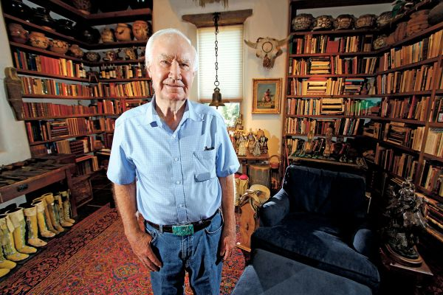

https://www.att.org/filebin/teachers_conf_day/5-minute-directions-quiz.pdf

Examples of different levels of newspaper articles:

Bright Pink is the World’s Oldest Color (13th July, 2018) Level 0
Scientists found that pink is the world's oldest colour. They looked at 1.1-billion-year-old rocks. They made powder from them and found a bright pink colour. A scientist experimented on the rocks. She said the pink colour came from tiny animals in oceans of long ago. The oceans are not here today.
The researcher was surprised when the rocks turned pink. She thought they would be black. She explained how important this news is. She said: "Imagine you could find [an old] dinosaur skin that still has its original colour - green or blue. That is exactly the type of discovery that we've made."
https://breakingnewsenglish.com/1807/180713-pink-0.html

Bright Pink is the World’s Oldest Color (13th July, 2018) Level 1
Scientists have found that bright pink is the world's oldest colour. Researchers looked at 1.1-billion-year-old rocks from the Sahara. They made powder from the rocks and found a bright pink colour. A scientist from the Australia National University experimented on the rocks. She said ancient organisms made the pink colour. They lived in old oceans that no longer exist. At that time, tiny organisms were the biggest life forms on Earth.
The researcher was amazed at the pink in the rocks. She thought the rock powder would be black, but it turned pink. Another researcher was also surprised that the 1.1-billion-year-old rocks "had this bright pink" colour. The scientist explained how important this news is. She said: "Imagine you could find a fossilized dinosaur skin that still has its original colour - green or blue. That is exactly the type of discovery that we've made."
https://breakingnewsenglish.com/1807/180713-pink-1.html

Bright Pink is the World’s Oldest Color (13th July, 2018) Level 2
Is the world's oldest colour black or dark grey? No. Scientists have found out that bright pink is the oldest colour. Researchers looked at 1.1-billion-year-old rocks in the Sahara Desert. They crushed the rocks into powder and found a bright pink colour. Dr. Nur Gueneli from the Australia National University led the research. She experimented on the rocks in a lab in Australia. She said the colour was made by ancient organisms that lived in the oceans. She added that those oceans no longer exist. At that time, tiny organisms were the largest life forms on Earth.
Dr. Gueneli said she was amazed when she saw the pink in the rocks. She thought the rock powder might turn black in their experiments, but it turned pink. Another researcher said: "Dr. Gueneli came running into my office and said, 'look at this,' and she had this bright pink stuff…It turned out to be real colour, 1.1 billion years old." Gueneli explained how important her find was. She said: "Imagine you could find a fossilized dinosaur skin that still has its original colour - green or blue. That is exactly the type of discovery that we've made."
https://breakingnewsenglish.com/1807/180713-pink-2.html

Bright Pink is the World’s Oldest Color (13th July, 2018) Level 3
Most of us might think that the world's oldest colour is black or dark grey. However, scientists have found out that bright pink is the oldest known colour. Researchers looked at 1.1-billion-year-old rocks deep beneath the Sahara Desert. They crushed the rocks into powder and found the bright pink colouring in them. This means that pink is the oldest colour on geological record. Dr. Nur Gueneli from the Australia National University led the research. She made the discovery in a lab in Australia. Dr. Gueneli said the colour was produced by ancient organisms that lived in the oceans. She added that the oceans are so old they no longer exist. At that time, tiny organisms were the largest life forms on Earth.
Dr. Gueneli said her first reaction was "sheer amazement". She said her team thought the rock powder might turn black when they were doing their experiments on it. Instead, it turned pink. Another researcher said: "I remember I heard this screaming in the lab. Dr. Gueneli came running into my office and said, 'look at this,' and she had this bright pink stuff…It turned out to be real colour, 1.1 billion years old." The rocks could contain other colours, from a blood red to a deep purple. Gueneli explained how important her find was. She said: "Imagine you could find a fossilized dinosaur skin that still has its original colour - green or blue. That is exactly the type of discovery that we've made."
https://breakingnewsenglish.com/1807/180713-pink.html

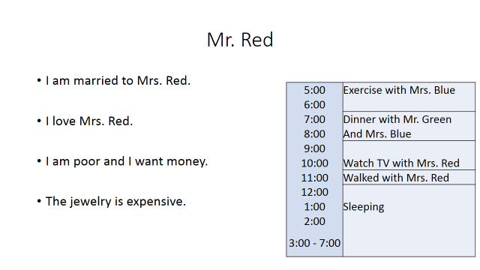
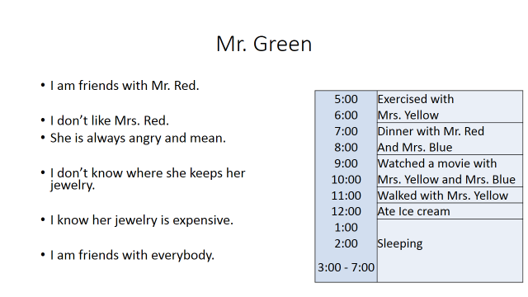
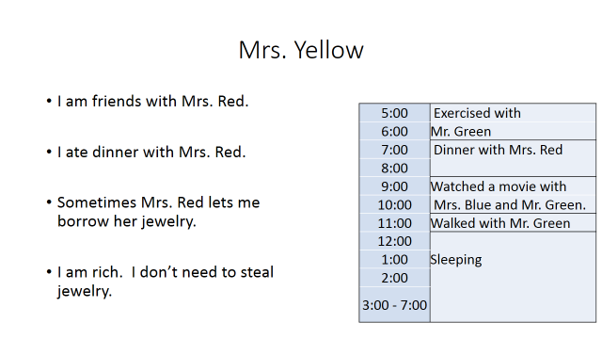
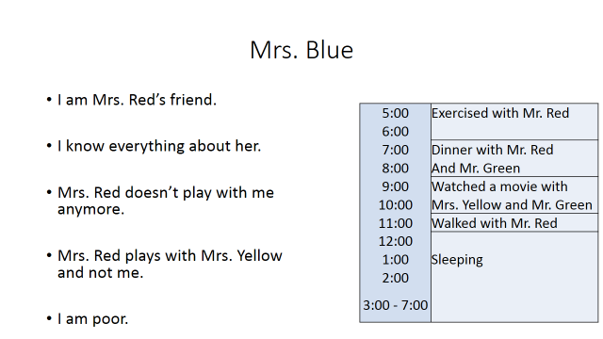

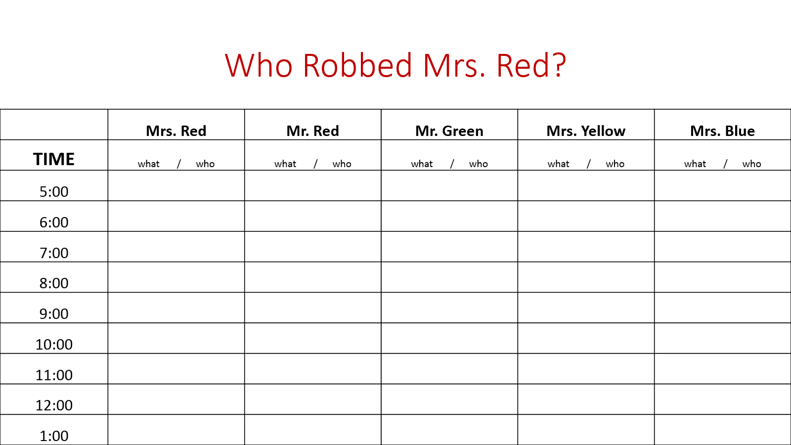
The Bread Problem: A
You are a single parent with 3 young children. Your partner (husband or wife) died last year. It’s been a very hard year for you and your family. You are barely making enough money to buy food. You have worked at a large bakery company for 3 years. The bakery makes about 5,000 loaves of bread a day. Occasionally there is a problem with a loaf of bread. You can still eat it but it isn’t the correct shape or color. Usually your bakery sells the problem bread to farms to feed animals. One day you are put in charge of packing and shipping the problem bread. You don’t get any extra pay for this new job but you get to work alone and listen to your earphones all day. After a few days of working alone you start to think, “Hmmmm nothing is wrong with this bread, maybe I can take a loaf home to my children. No one will notice if one loaf is gone, it’s a huge company. They make billions of won from this bread while I make 만원 an hour!”

- Do you take the bread or not?

- Why did you make this choice?

- What are some good and bad consequences that could come from your choice?

The Bread problem: B
You are a single parent with three young children. You have worked at a large bakery company for 3 years as a manager. The bakery makes about 5,000 loaves of bread a day. Occasionally there is a problem with a loaf of bread. You can still eat it but it isn’t the correct shape or color. Usually your bakery would throw it away but you have come up with an idea to sell the problem bread to farms to feed animals. You need a new supervisor to run this new program so you give the job to a regular worker because the job is not too difficult and you know this person has had a hard time since their partner (husband or wife) died of cancer last year. Unfortunately, they don’t get a raise but you think it will help them to do something different at work and maybe they will get noticed for a better job in the future. Everything is going well until your manager tells you that the farms are not getting the amount of bread they are paying for. Sometimes there are 4-5 loaves of bread missing. You start to investigate and see and see your new supervisor taking 1 or 2 loaves of bread.

- Do you report the new supervisor or make up a lie to cover up their theft?

- Why did you make this choice?

- What are some good and bad consequences that could come from your choice?

Moonasar, D. (2018). Secondary – Strive to Thrive In: 2018 GEPIK Teacher Training Program. Gyeonggi-do Institute for Language Education, pp. 170-172.

