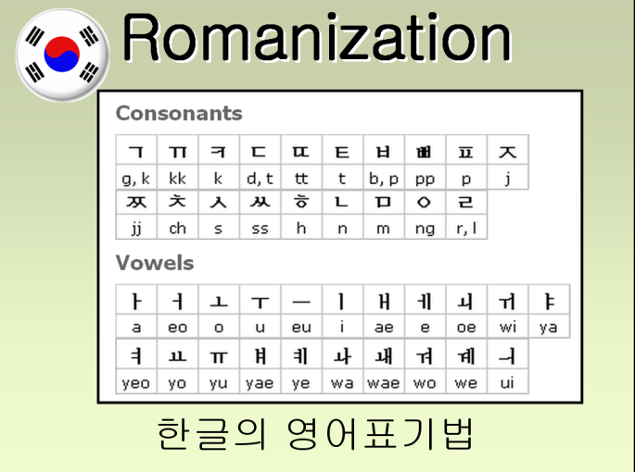
Korean Romanization:
비빔밥 =
서울 =
평택시 =

Write your name: ____________________________.
Introduction
Hello, my name is _______________________________.
1st Time:
2nd Time:

Age

Birthday

Place

Job

Something Interesting

Family
- I have _____ family members.

