Nationalities

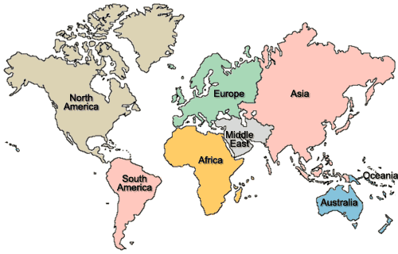

Asia =
Africa =
Europe =
North / South America =
Middle East =
Australia =

Korea =
Canada =
USA =
China =
Japan =
England =
France =
Greece =
Germany =
Netherlands =
Spain =
Thailand =

