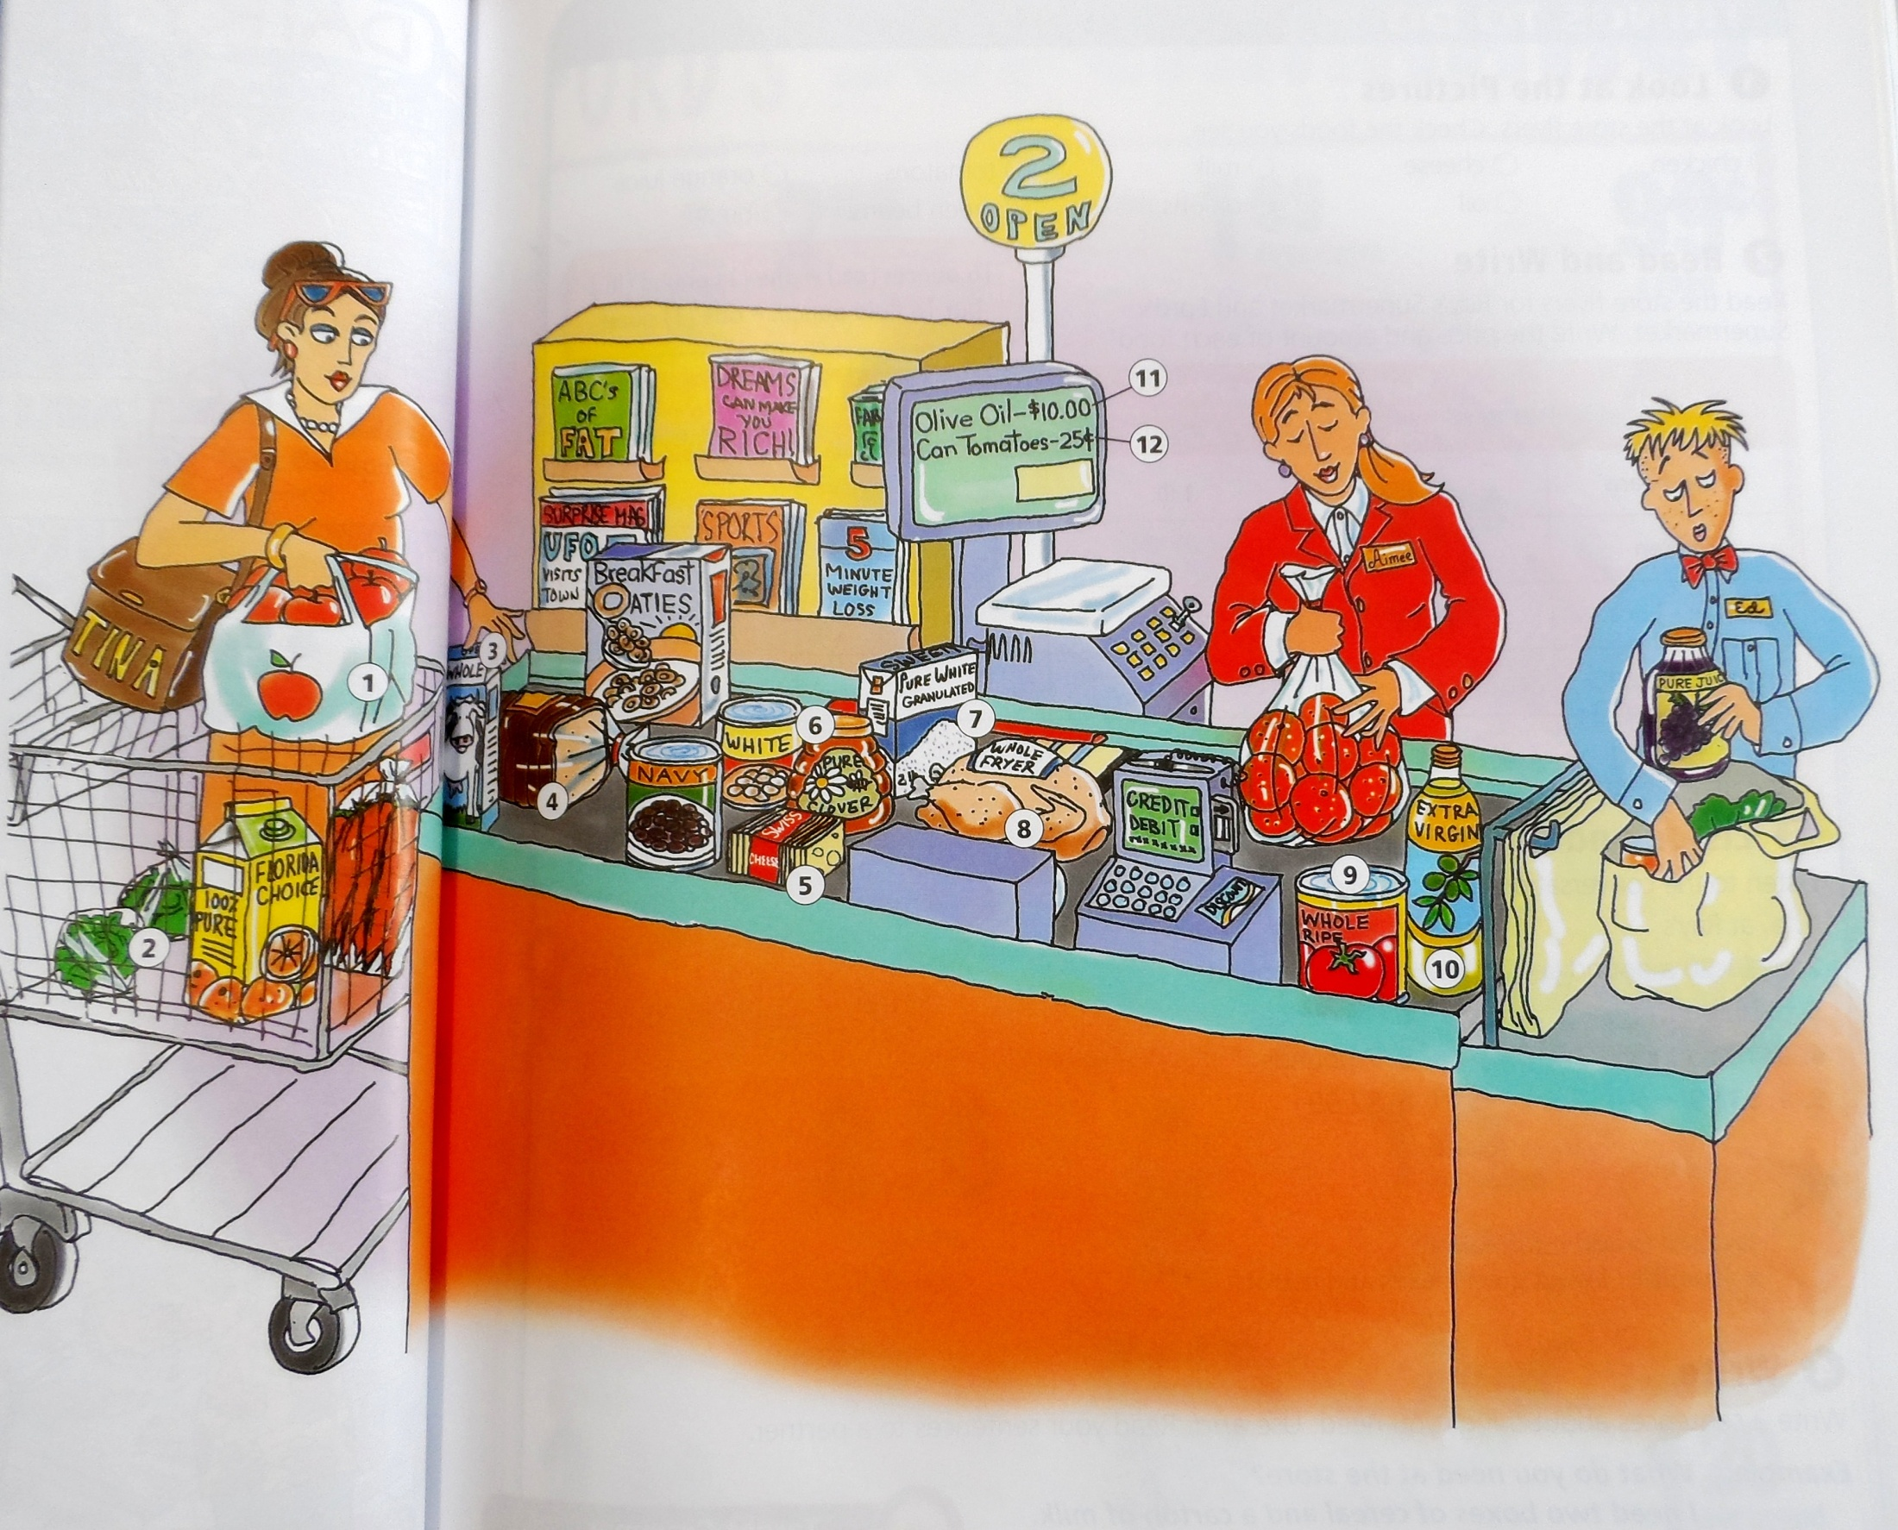

- ___________ of apples

- ___________ of lettuce

- ___________ of milk

- ___________ of bread

- ___________ of cheese

- ___________ of honey

- ___________ of sugar

- _________ of chicken

- _________ of tomatoes

- ________ of oil

- ______________

- ______________

