Ordering Food (at a restaurant)
Man =
Woman =

Hello, May I take your order?

- What dish do you recommend?
Recommend =

I’d like…

How about =
- How about _________________?
No, I don’t like curry.
- How about _________________?
That sounds delicious, I love rice.
- How about _________________?
Ok, we can share the meat.
- How about _________________?
I don’t really want that. How about the cheese pizza?
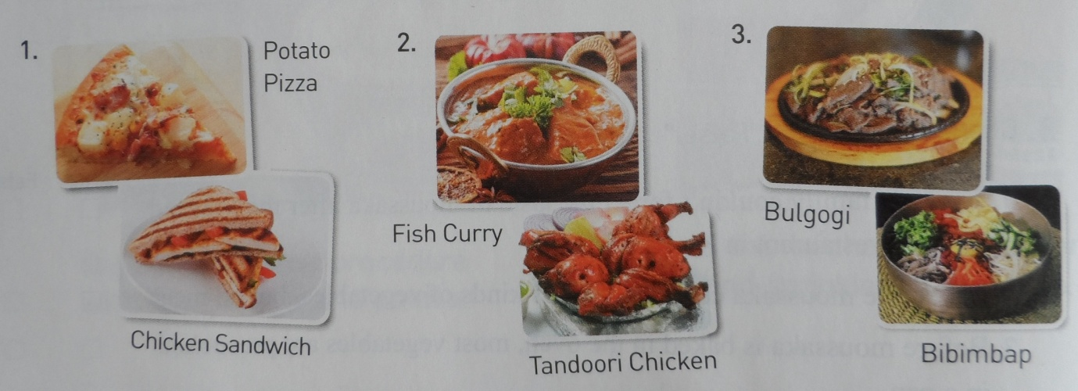

맛있게 드세요

When you are finished eating, what do you say?

TIPS

When?
- Sit-down Restaurant

- Alcohol Drinks

- Very Good Service

- Drivers

How Much?

Gratuity = ______________

Why?
- Waiters / waitresses are not paid minimum wage.
- Tips are part of their income.

