**Statement**

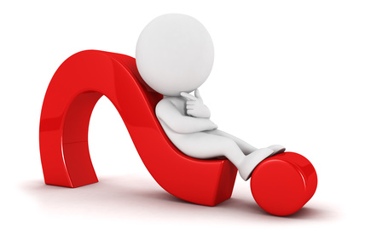(Pronoun) + (to be + adjective)?

It **is** round.

**Is** it round?

**Helping Verbs**

What is a verb?

What is a helping verb?

1. 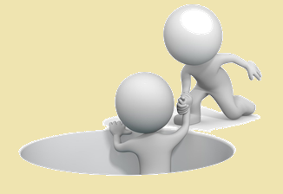He was eating pizza.
2. We can go home now.
3. They have watched a lot of movies.
4. The teachers have treated us kindly.
5. I would like a hamburger, please.

**Other Statements**

(add Does / Do)

Simple Present Sentence (like, love, want, have)

**Review**

1. The Eiffel Tower is tall.
2. She can play the piano.
3. The pizza is circular and flat.
4. They love candy.
5. You have a metallic ruler.

**How to Answer**

Is it green?

Has she read the book?

Do you like the cafeteria food?

Are you tired?

