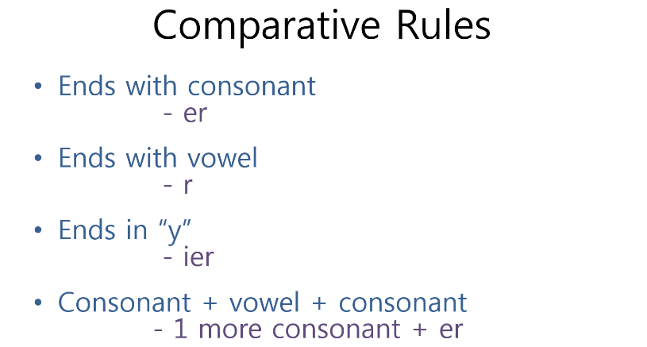**Comparatives and Superlatives**

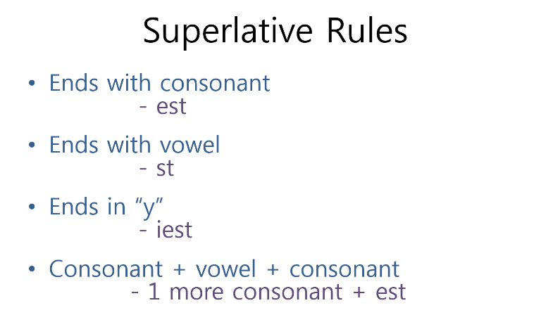



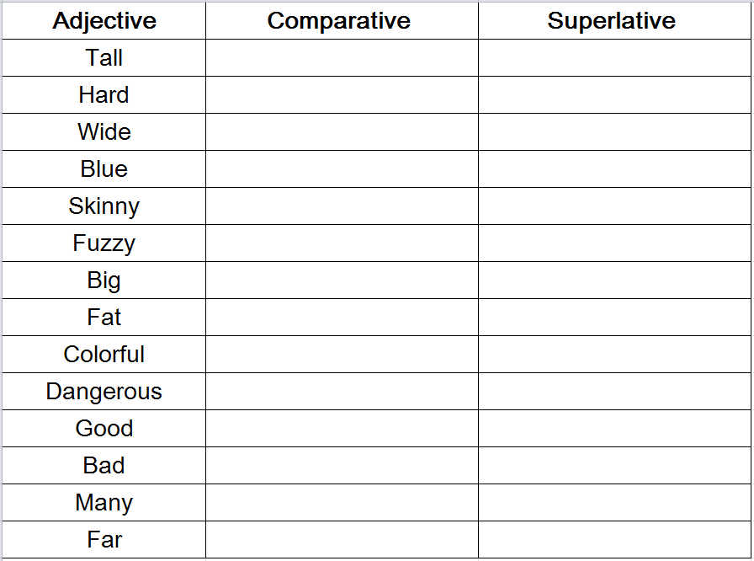

_______ is (comparative) than ________.

___________ is the (superlative).

