Comparatives and Superlatives
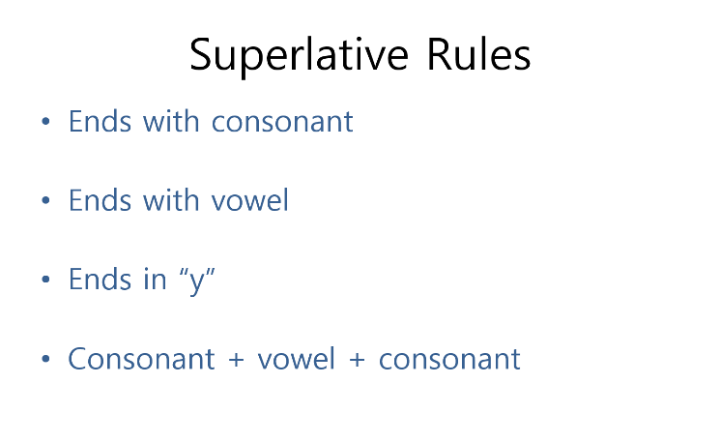
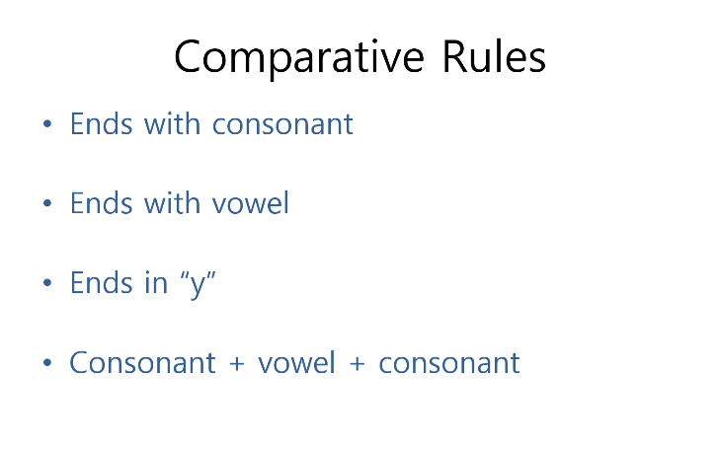

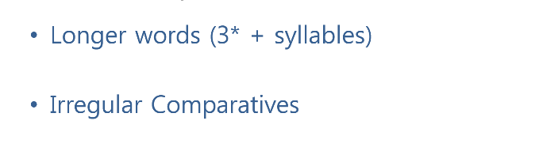

Adjective | Comparative | Superlative
Tall
Straight
Blue
Nice
Happy
Tiny
Big
Fat
Colorful
Spherical
Good
Bad
Many

______ is (comparative) than ______.

______ is the (superlative).

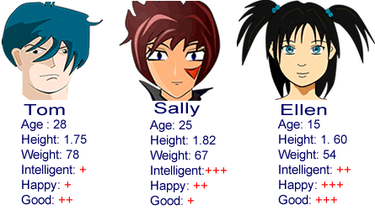
- Who is taller, Sally or Ellen?
- Who is happier, Tom or Ellen?
- Who is smarter, Tom or Sally?
- Who is worse, Tom or Ellen?
- Who is heavier, Sally or Ellen?
- Who is younger, Sally or Tom?
- Who is the tallest?
- Who is the saddest?
- Who is the youngest?
- Who is the best?
- Who is the oldest?
- Who is the smartest?
- Who is the lightest?
- Who is the worst?
- Who is the most stupid?

