Opinion vs Fact

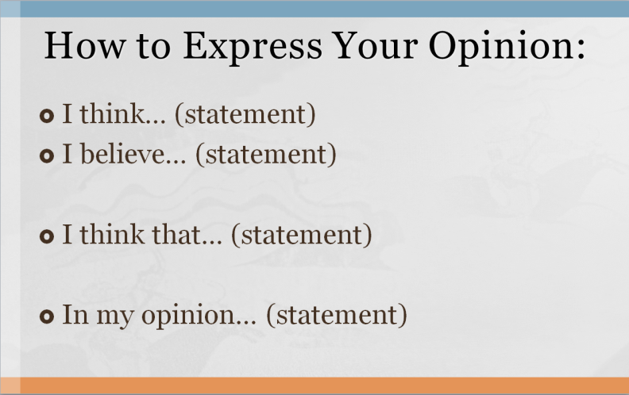
Opinion List
Beautiful / Pretty / Gorgeous
Handsome / Attractive / Good-Looking
Cute / Adorable
Ugly / Disgusting
Good / Better / Best
Bad / Worse / Worst
Amazing / Fantastic / Wonderful / Incredible
Boring / Dull
Mean / Rude / Inconsiderate
Smart / Clever / Intelligent
Exciting / Thrilling / Exhilarating
Valuable - Worthless - Priceless
Useful - Useless
Difficult - Easy
Dirty (messy) - Clean (spotless)
Smart (intelligent) - Stupid (dumb)

