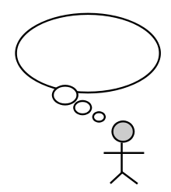
I think… (statement)
I believe… (statement)

I think that… (statement)
In my opinion… (statement)

Choose one of the questions:
- What do you think about school life?
- What do you think about America?
- What do you think about animals in zoos?
- What do you think about social media?
- What do you think about travelling to mars?

Which Question? What do you think about _________________?

