Name: Date:

**Directions 1**

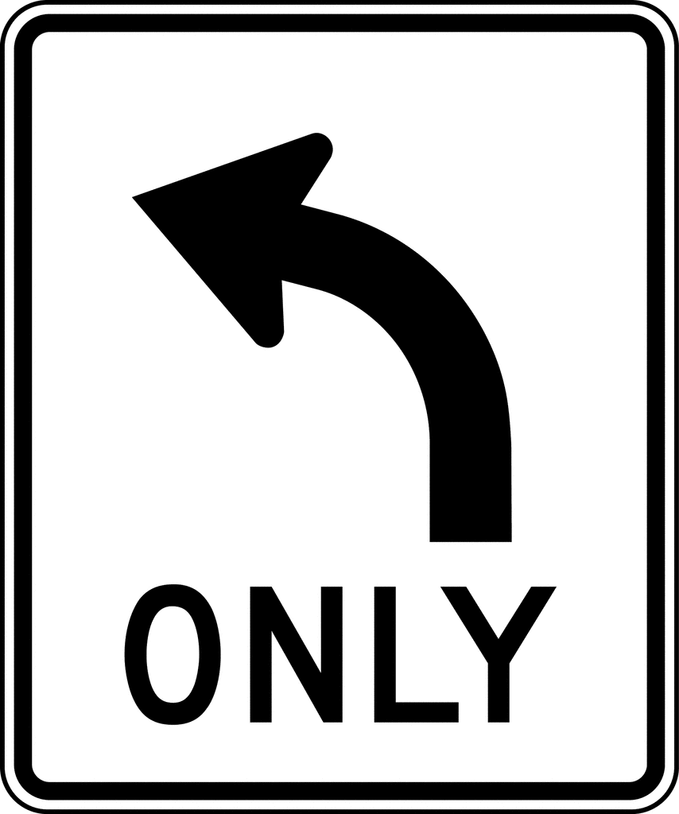 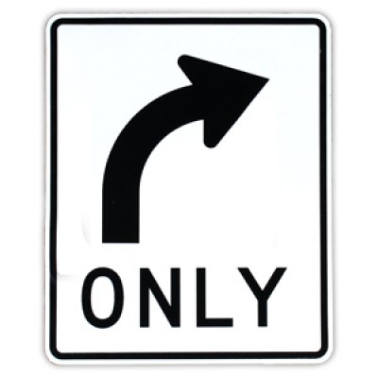 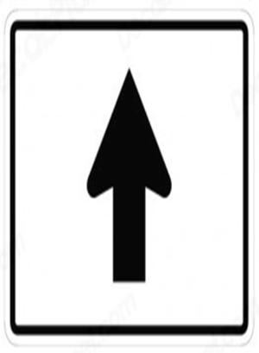 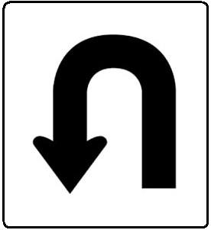

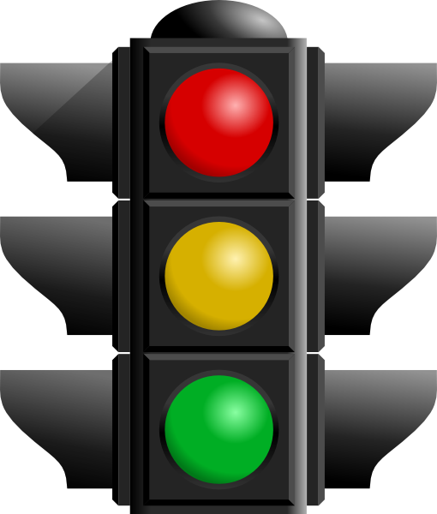

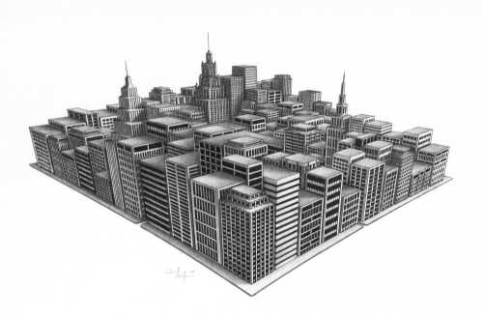 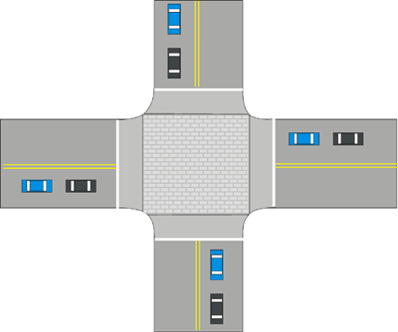

Go straight for ___________ ____________.

At the intersection of _______________ and _____________,

Turn ____________ on ______________.