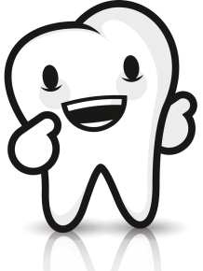
Would you rather…?
Would you rather (_____)_____ or (_____)______?
2 things =
0 things =
Doesn’t matter =

Would you rather go to the dentist or have a toothache?

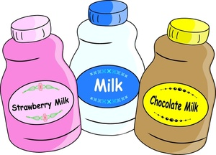
Would / Do you prefer (_____)______ or (_____)_____?

Would / Do you prefer chocolate or strawberry?

Name | Choice 1: | Choice 2:

