Name: Date:
My Opinion

Opinion =

 | fact | opinion
1+1 = 2
The earth is round.
Girls are smarter than boys.
The pyramids are very old.
Dinosaurs lived in large groups.
If I drop a ball, it will fall to the floor.
Blue whales are the largest animals to ever live.
Eating healthy makes you feel happier

I think _______________.

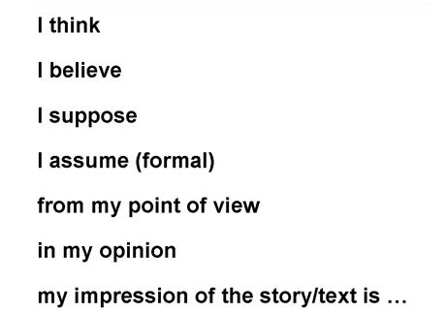

What is the best place to live?

What is the best video game?

Who is the worst superhero?

Agree Disagree

