What are some fun things to do on the weekend?

Verb Tense:
Past =

Present =

Future =

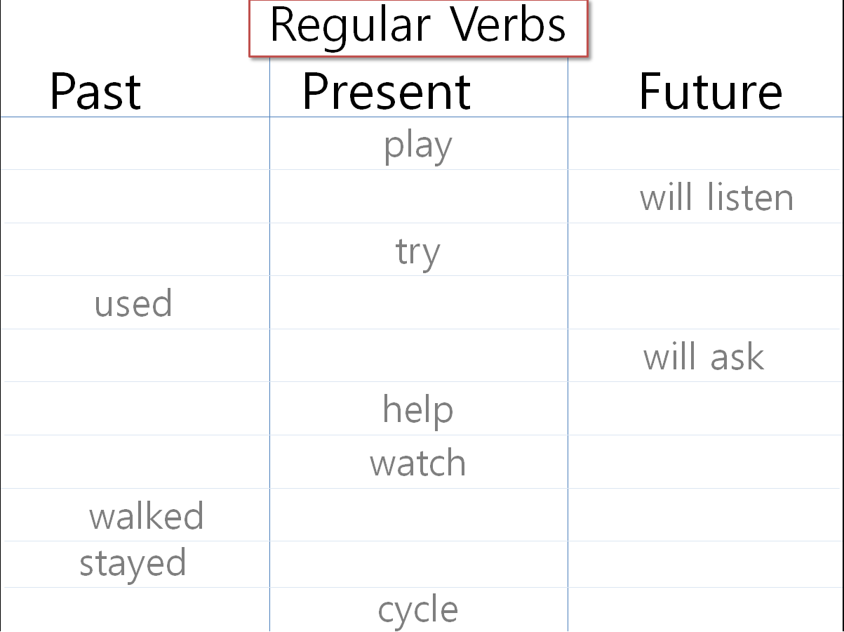

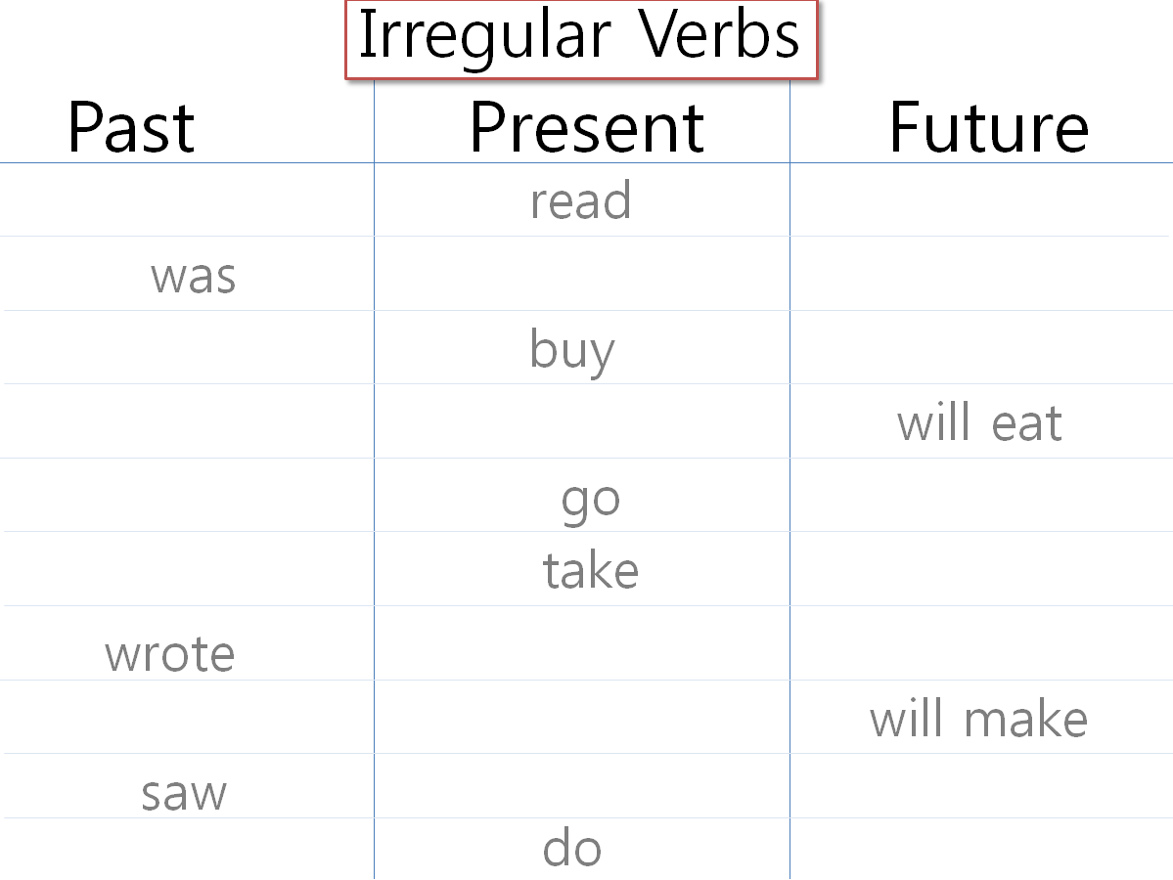

At year

On day

In time

- When do you eat breakfast?

- When is your birthday?

- When were you born (year)?

