What are ordinal numbers?

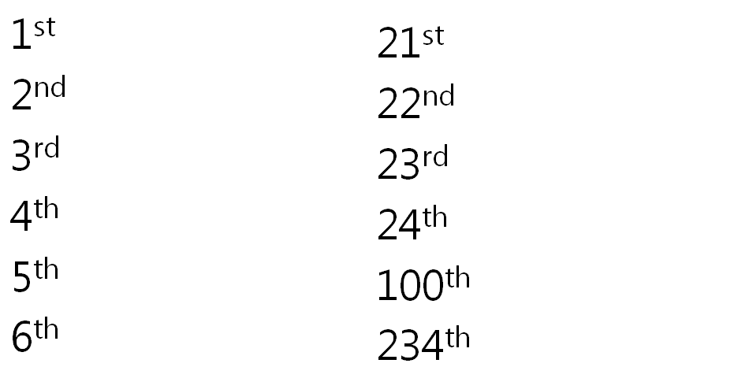

#1 –

#2 –

#9 –

#17 –

#55 –

#88 –

#98 –

On the Calendar:
When is New Year’s Day?

What day is it today?

