________________________
________________________
________________________
________________________
________________________
________________________
________________________
________________________
________________________
________________________
________________________
________________________
________________________
________________________
________________________
________________________
________________________
________________________
________________________
________________________
________________________
________________________
________________________
________________________
________________________
________________________
________________________
________________________
________________________
________________________
________________________
________________________
________________________
________________________
________________________
________________________

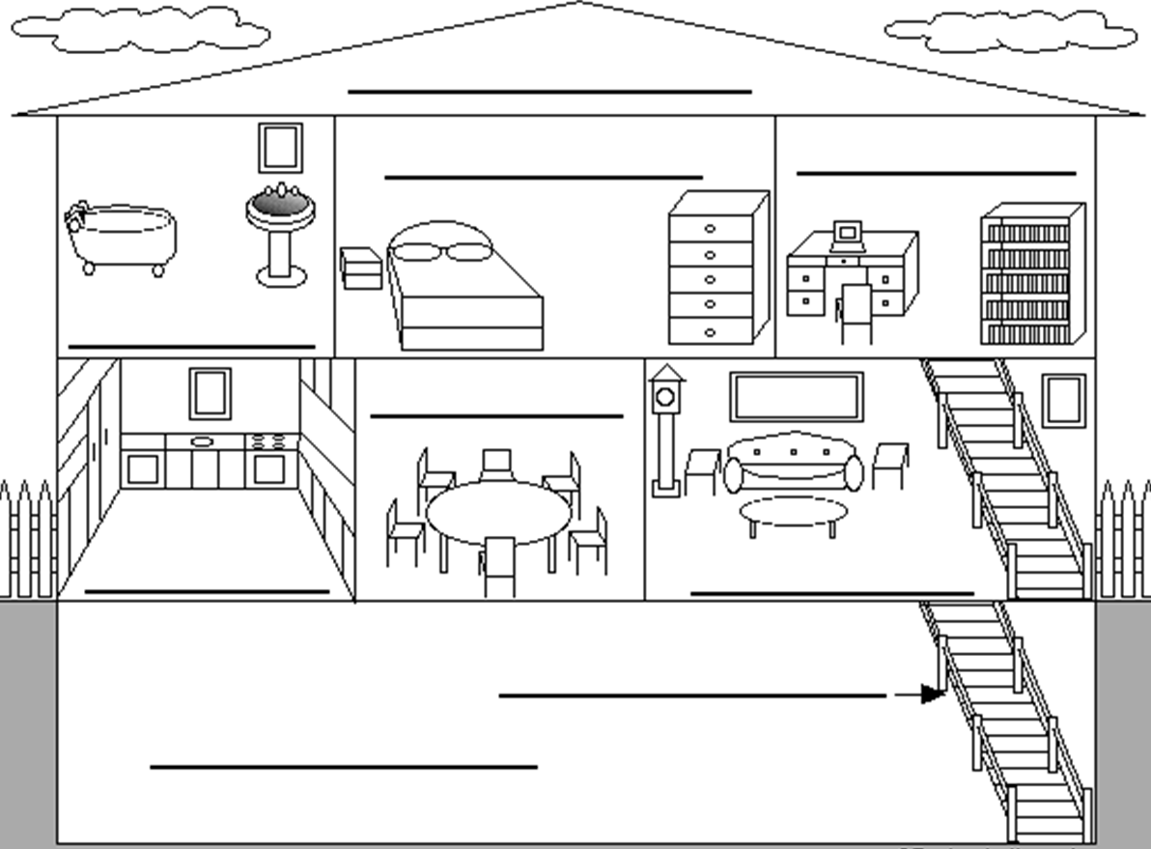

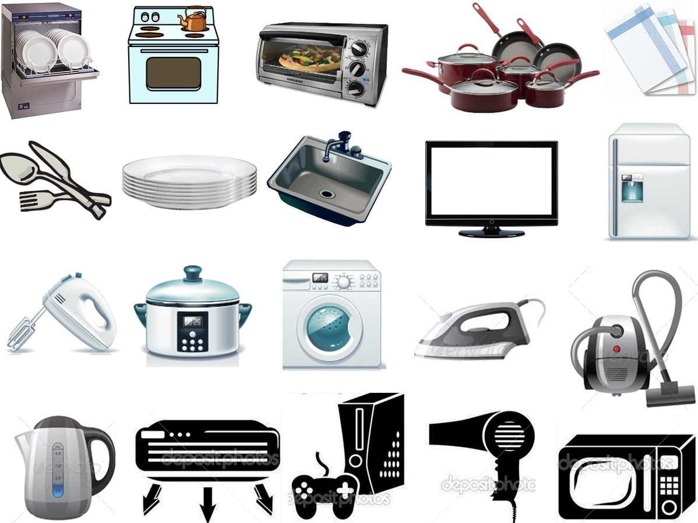

1st Floor
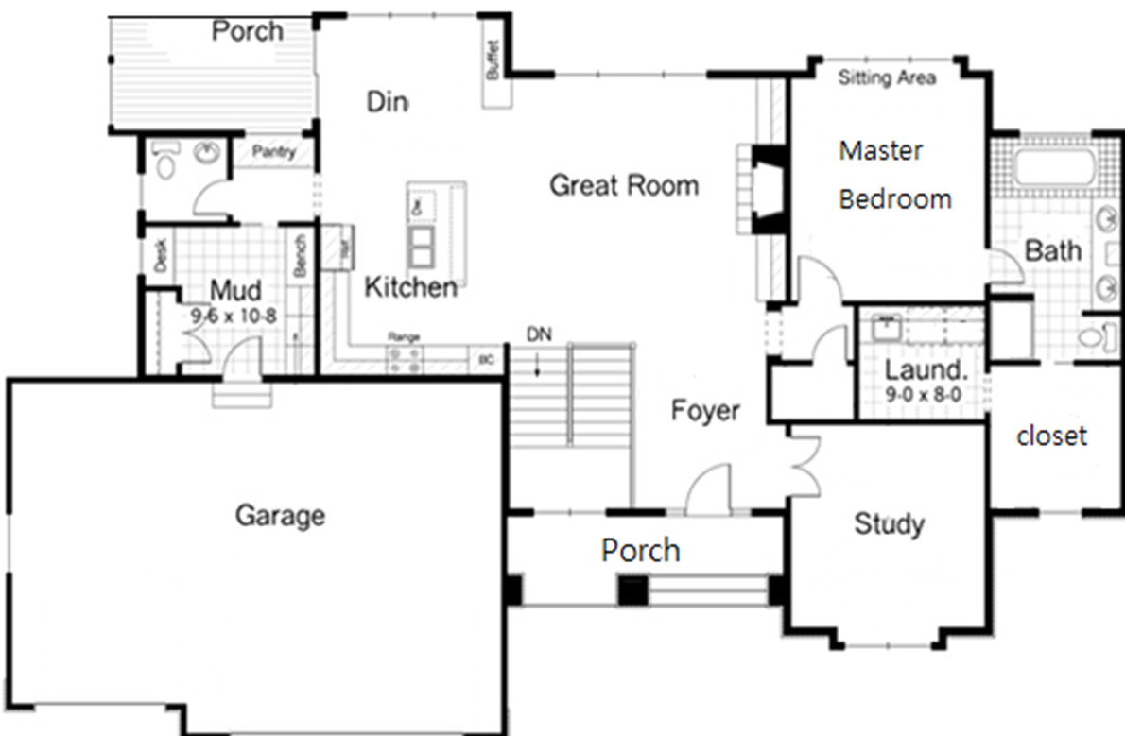

Basement
