Sugar

Why do we need sugar?

American Heart Association’s recommendations:
Men – grams/day, teaspoons/day, calories/day
Women – grams/day, teaspoons/day, calories/day

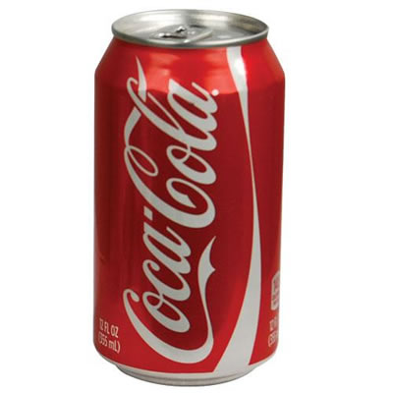
= grams of sugar

= teaspoons of sugar
How many calories per year? _______

Which is the good sugar?

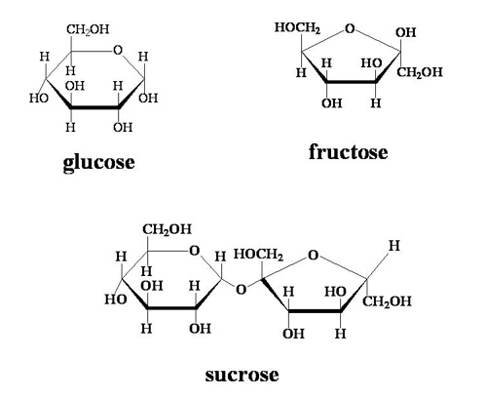

Circle what sugar does to our bodies:

