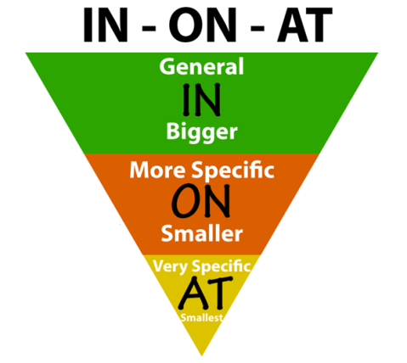
Year
1983 =
2017 =
1503 =
2007 =
- Donald Trump became president in 2017.

Month
- The Pyeongchang Olympics were held in February.

Day
- Isaac Newton was born on January 14th, 1643.

Time
- We will meet for lunch at 11:30.

When did I make the PowerPoint?
- The PowerPoint was made …
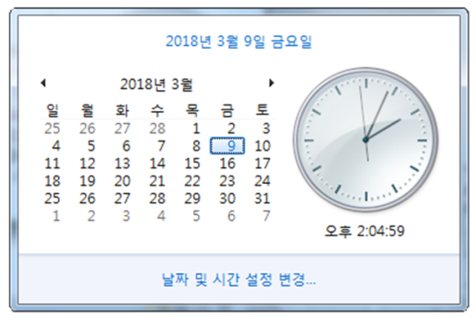
Year =
Month =
Day =
Time =

