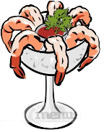
Menu
Apetitizer
Platter =
- Small amount of food
Dish

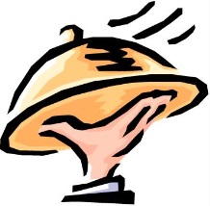
- It will make you hungrier for the main dish
Entrée (Main Course, Main Dish)
- This is the main part of the meal.
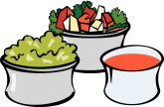
- In North America, this is usually meat, vegetables, and potatoes (or rice).
On the side
(you can also order part of the main dish to be separate – usually the sauce)
Sides (Side Dish, Side Order)
- Something you can add to your meal.
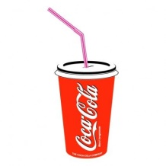
- Usually served to the ‘side’ of the main dish.
Soft Drinks

Beverages (Drinks)
- Water is usually free, but these are other options.
Dessert
- After your meal is finished
A la mode =
- Sometimes a restaurant has a second menu for desserts.
Soup de jour =

Cooking Vocabulary (How it’s made)

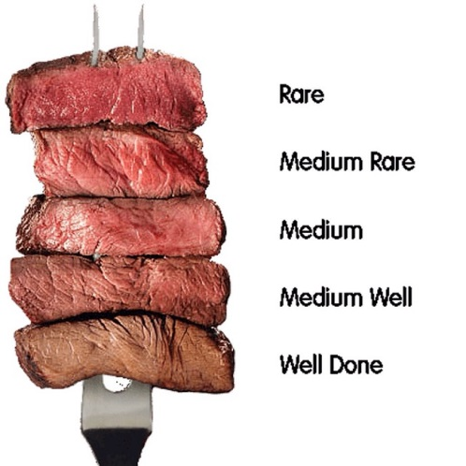

A la carte =
_________________ = no meat (sometimes milk, fish, eggs)
_________________ = no animal products (no milk, honey, eggs)
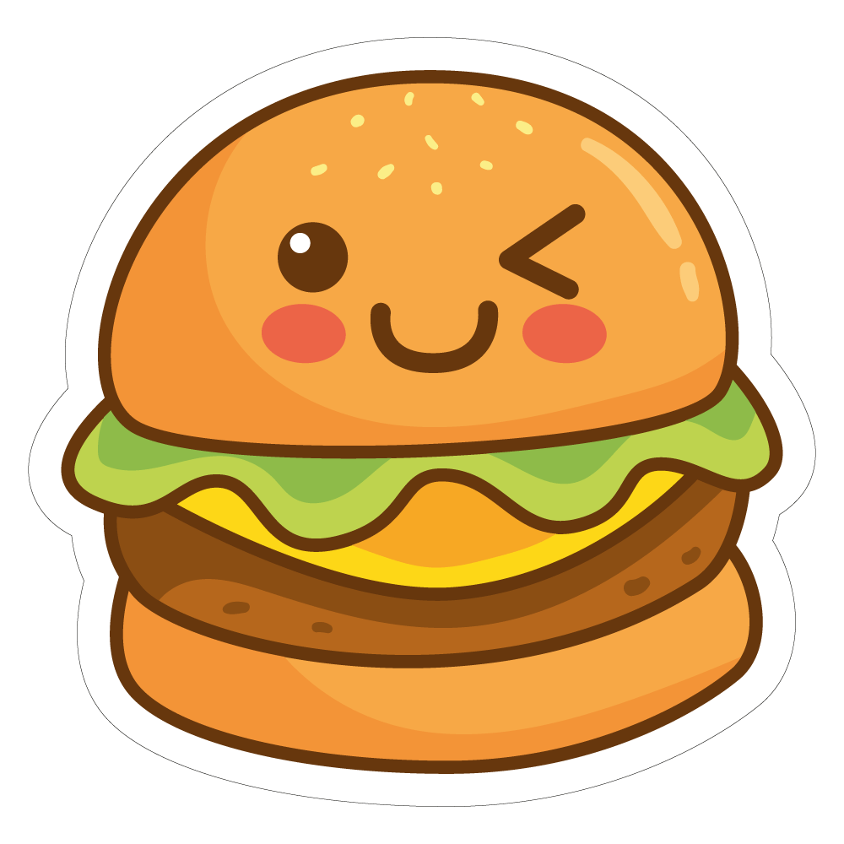
Toppings
- Something that goes on the food.
- Pizza, hamburger, etc.
“Give me the works” =
“Hold the pickle” =

Paying the Bill
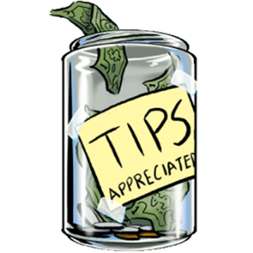
            - Tips / gratuity
            - Western Culture

            - Give extra money for good service.
“How would you like to pay?”
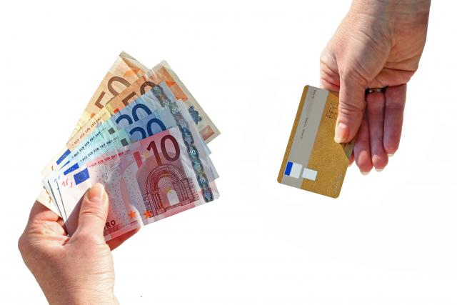

“It’s on the house” =

