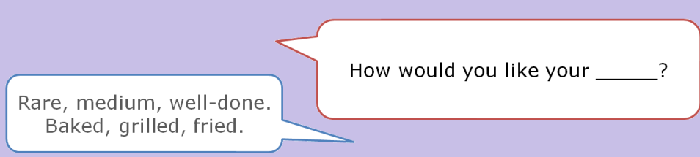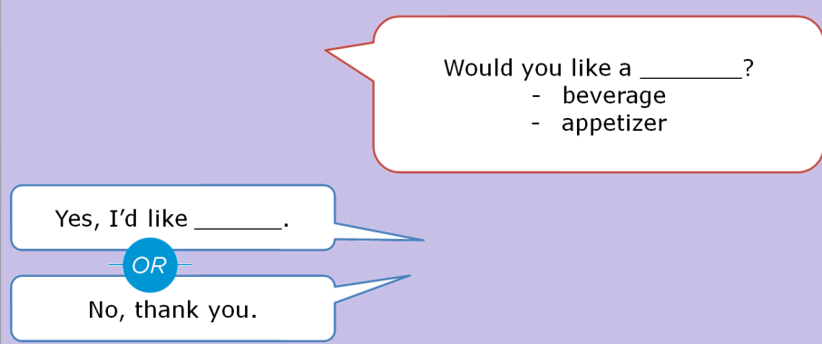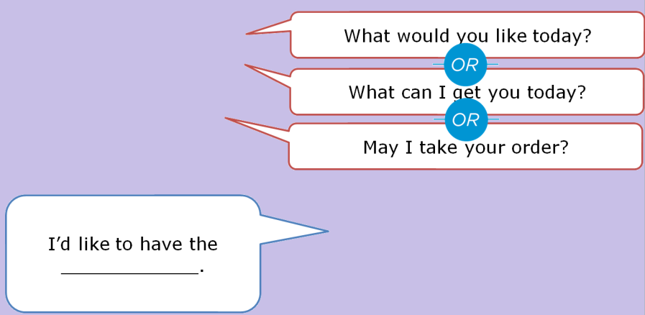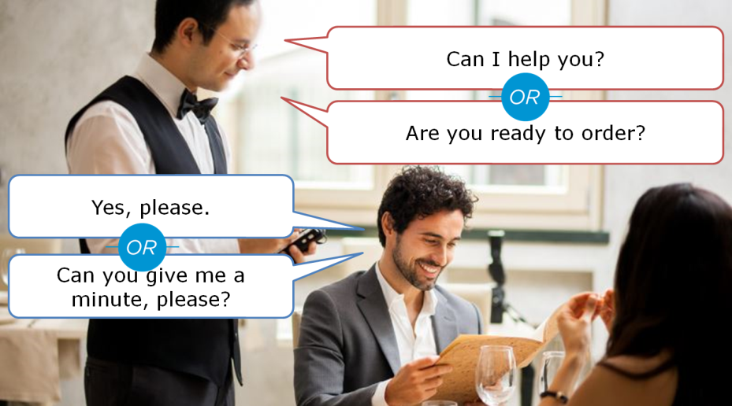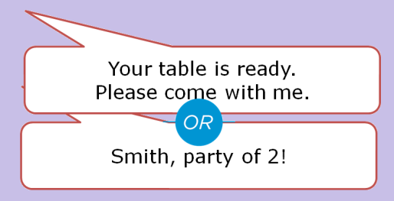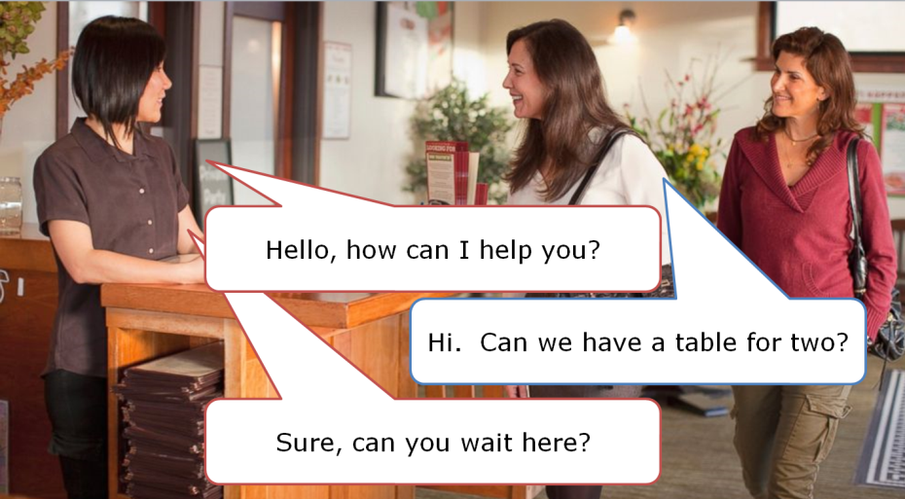

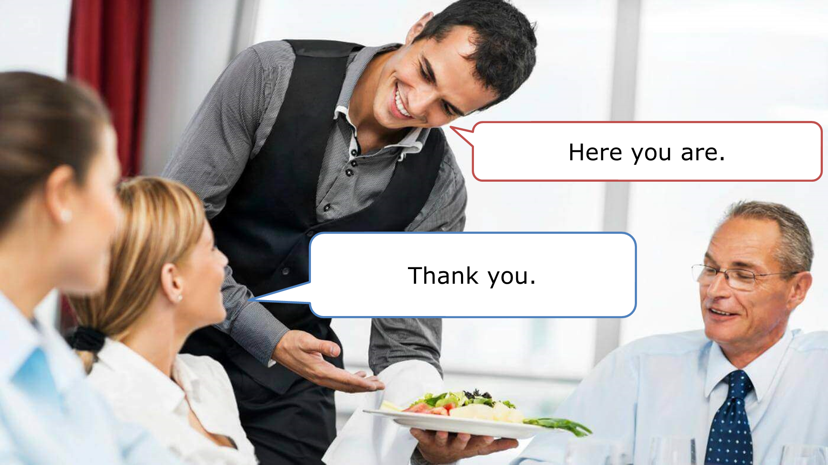

Yes, it’s great.

Is everything ok?





No thanks, can I have the bill?

Yes please, can I see the dessert menu?

Can I get you anything else?

Could I have _____?

**Paying the Bill**

* Tips / Gratuity
* Western culture
  + - About 10 – 20%
    - Tip the tax
    - Give extra money for good service.
* How would you like to pay?
* Cash
* Debit
* Credit card