TENS
21 = twenty-one
22 =
36 =
81 =
79 =
HUNDREDS
100 = one hundred
345 =
872 =
911 =
777 =

THOUSANDS

1,000 =
10,000 =
100,000 =
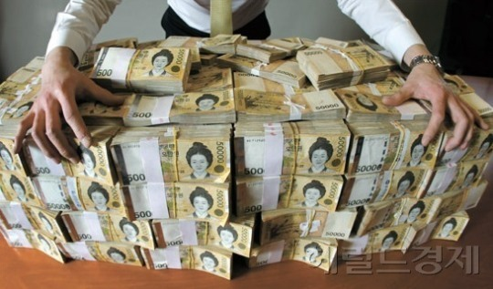
1,000,000 =

- 만원 =
- 억 =
- 조 =
987,654,321 =

ORDINALS
1st = first 5th =
2nd = second
3rd = third 21st =
4th = fourth 25th =


FRACTIONS
1/5 = ½ =
1/10 = ¼ =
1/55 = ¾ =
2/3 =

DECIMALS
0.1 = zero point one
0.10 =
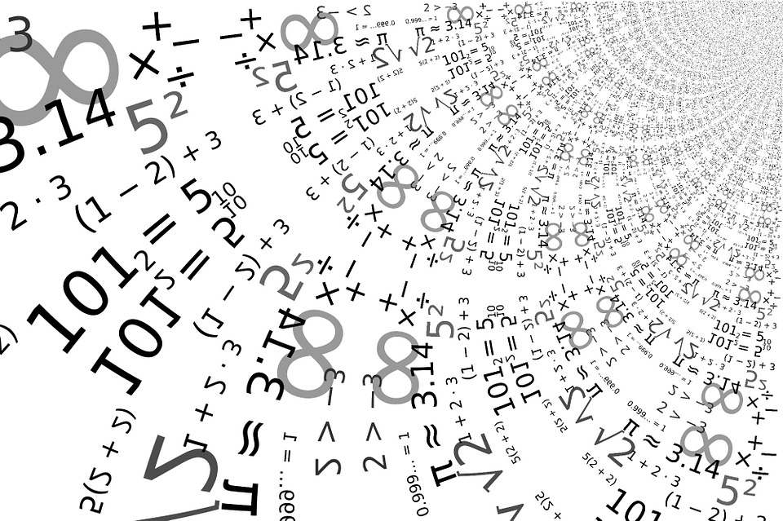
7.3429 =

MATH
+ = plus
ㅡ = minus
X = times
÷ = divided by

1/3 of = times

