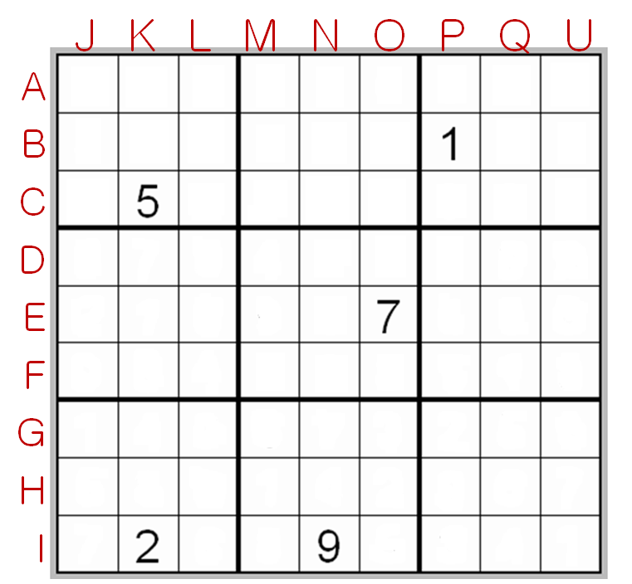
A: Three hundred ninety-one million, two hundred eighty-six thousand, five hundred and seventy four.
F: (One-hundred seven million, one-hundred sixty-nine thousand, eight-hundred and fifty-seven) times nine.
G: One fifth of (seven-hundred forty-eight million, three hundred sixty-six thousand, two-hundred and ninety).
J: (Two-hundred twenty-two million, two-hundred twenty-two thousand, two hundred and twenty-two) plus (one-hundred twenty-four million, six-hundred six thousand, nine-hundred and thirty-five).
M: Half of (four-hundred seventy-four million, nine-hundred ninety-one thousand, two-hundred and thirty six).
Q: One billion minus (two-hundred seventy-six million, eighteen thousand, four-hundred and thirty-six).

