Author:
Title:
Topic:
Audience:
Thesis = Topic + Opinion + Reasons
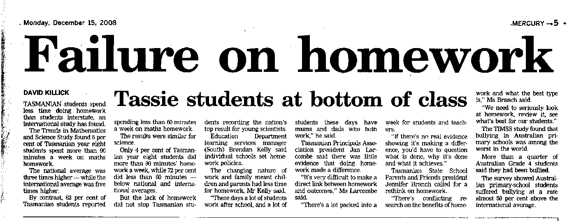
Main Ideas?

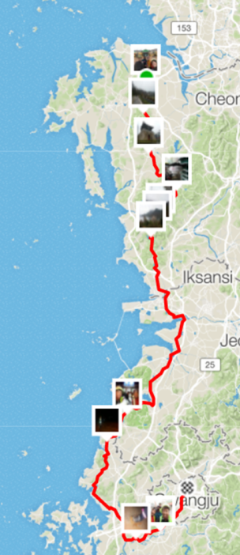
Fleche Report
Author:
Title:
Topic:
Audience:
Thesis?

Main Ideas

Questions:
What is “fleche”?
Where did they go?
How was the weather?
Why did James and Darnell miss the turns?
What is a 22 hour control (why do they have it)?

List the ‘mechanical issues’ they experienced:

