The Process of Elimination
Process
- A series of steps or actions to achieve a goal
- a way of doing something
Elimination
- Removal or destruction of something
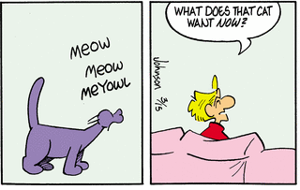
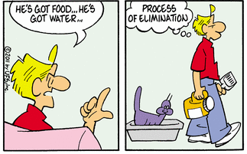
THE PROCESS OF ELIMINATION
- Create a goal
- Start by brainstorming ideas
- Test the ideas
  - failure = eliminate
  - success = don’t eliminate
- Continue until only one idea is left

Our Goal: To defeat the zombies
Ideas:

Solution:

