Present Perfect Tense
An Action that started in the past, but continues (not finished).
An action but the time doesn’t matter.

Present Perfect = ________ “to have” + past participle _________.

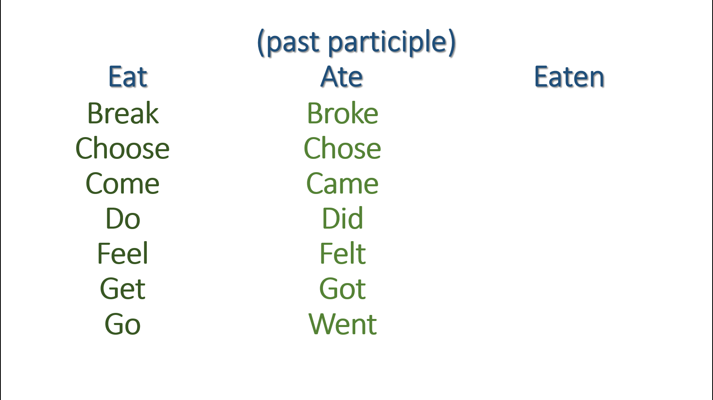

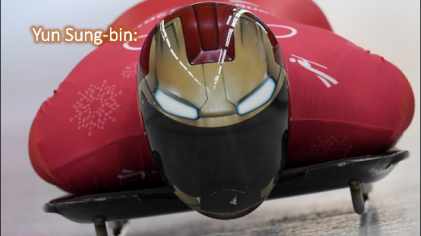

He won a gold medal.
He has been to the Olympics before.
He has practiced skeleton since 2012.
In 2016, he received a Rookie Award at the 21st Korean Athletics Awards.

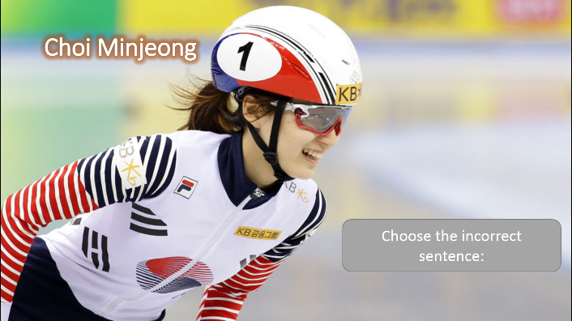

1. She won a gold medal for ladies 1500m
speed skating this year.
2. She has been skating since 2004.
3. In November 2016, she has gotten the world record for 1500m speed skating.
4. She received the Top Player Award at the 2016 Korean Women's Sports Grand Awards
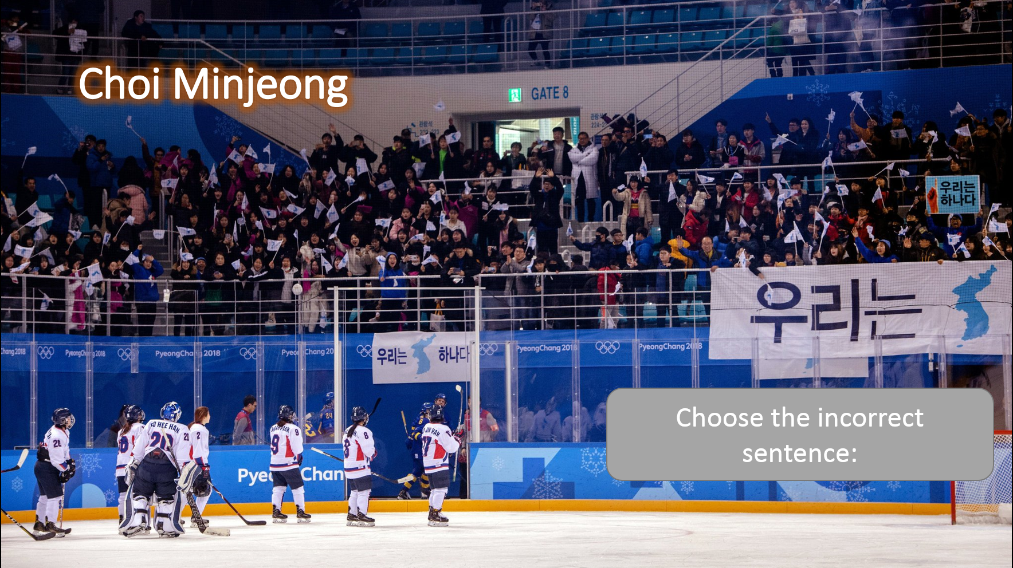
1. North and South Koreans played hockey together.
2. There has been players from other countries too.
3. Randi Griffin has been playing on the Korean hockey team since 2014.
4. She was born in American, but naturalized to Korea in 2014.

1. The unified Korean flag __________ used by the hockey team.
2. It ___________ used since 1991 any time North and South Korea compete together.
3. It ______________ first used in the 1991 World Table Tennis Championships.
4. The women’s team even _____________ a gold medal at the championships.

