Past Perfect Tense
- Something that happened in the past and something else happened after that. (before / until)
Past Perfect Tense = _________ “had” + (past participle) ___________.
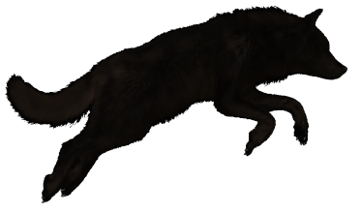
Practice
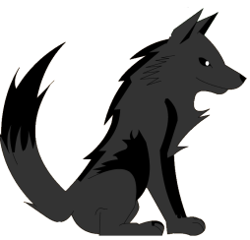
- She _________ lived in South Africa for three years before she moved to England.
- Before I knew it, my dog _________ run away.
- He _______________________ two hours before the bus finally came.
- I didn’t say anything until she _________________________ talking.
- I _______________________ enough to eat, but I still ate dessert.

Past Perfect vs Present Perfect
- She (had / has) lived here since she was 10 years old.
- He (had / has) lost his wallet a long time before going to the theater.
- Until I turned 21, I (had / has) never driven a car.
- I (had / has / have) been to Europe.

By the early 1990s, gray wolves (A) had begun / have begun to disappear from Yellowstone National Park in the US, and this resulted in a growing elk population. The elk ate too many leaves from the trees, which reduced shade along the rivers and creeks. This caused water temperatures to increase and the populations of many fish species in the park (B) declined / had declined. To restore balance to Yellowstone’s ecosystem, sixty-six gray wolves from Canada were released into the park. As a result, the number of elk quickly dropped. Now, the ecosystem has returned to its natural balance. This story shows how crucial some species are for the health of an entire ecosystem. If we (C) respect / will respect all species equally, we’ll be able to continue to enjoy the natural world.
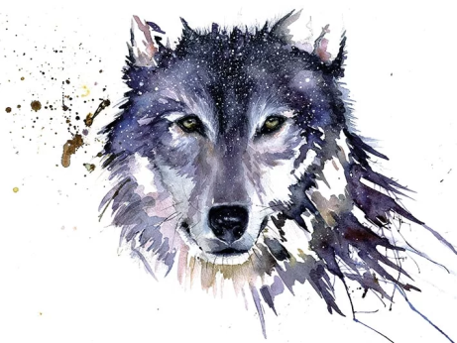

Video Question:
What are some keystone species?

