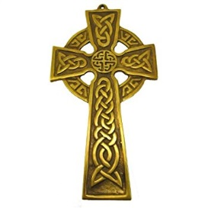
St. Patrick’s Day Symbols
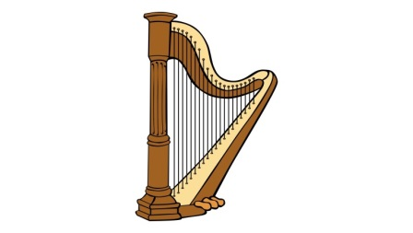

Saint Patrick's Day, March 17, is an annual (1) ____ of the patron saint of Ireland. It is a national holiday in Ireland, and millions of Irish people all over the world where there are Irish (2) ____ celebrate. Celebrations are based on all (3) ____ Irish and the color green. City authorities in Chicago even (4) ____ the city’s river green for this day. Many people wear green clothes, eat Irish food and drink the Irish drink Guinness, which many bars also try and dye green. There are also traditional St Patrick’s Day parades. The (5) ____ in Dublin is spread over five days and attracts half a million people. The New York parade is the largest, with two million spectators. Many people with (6) ____ Irish connections celebrate and declare themselves Irish for a day.

Saint Patrick was a Christian missionary. Some (7) ____ say he was born in England, while others believe he was Italian. Most agree he lived in the fifth century. When he was sixteen, he was captured and taken as a (8) ____ to Ireland. He lived as a slave for six years before (9) ____. He joined the church to train as a priest and became a missionary in the north and west of Ireland. Legend has it that Patrick (10) ____ all the snakes out of Ireland. There are many other legends about Patrick that have cemented him as a key part of Irish culture. March 17 is (11) ____ to be the date of his death. Unlike other saints, Patrick was never canonized by a Pope, although most Christian churches (12) ____ him as a “Saint in Heaven”.

